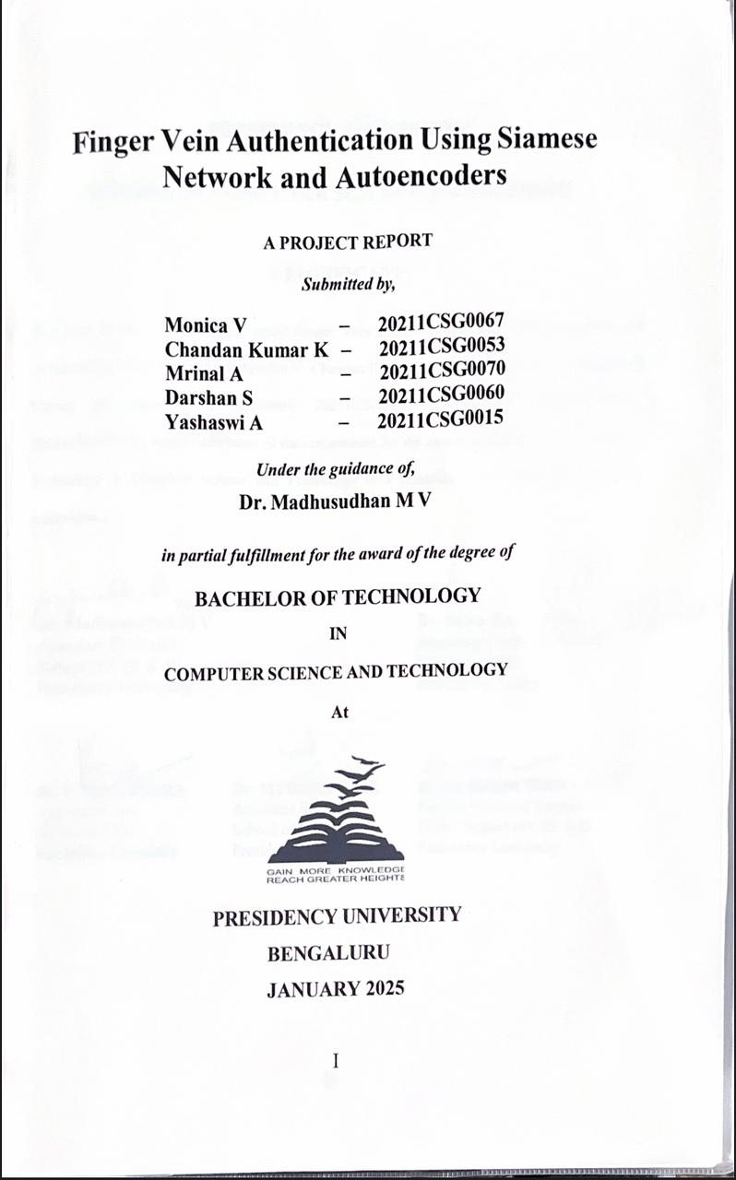

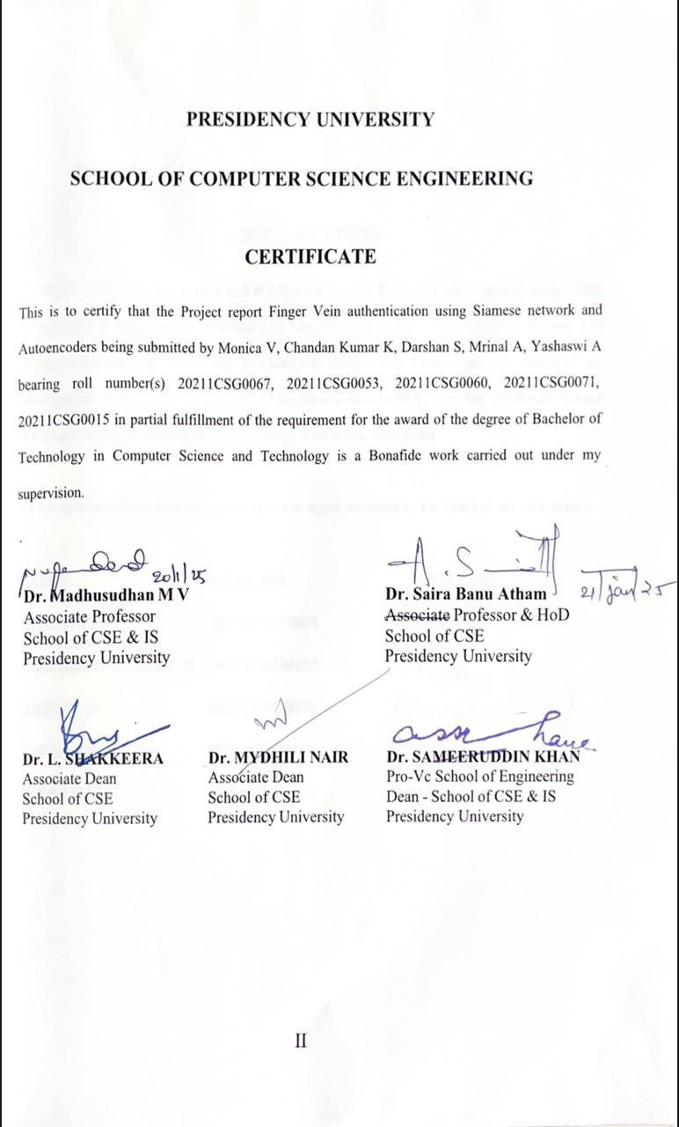

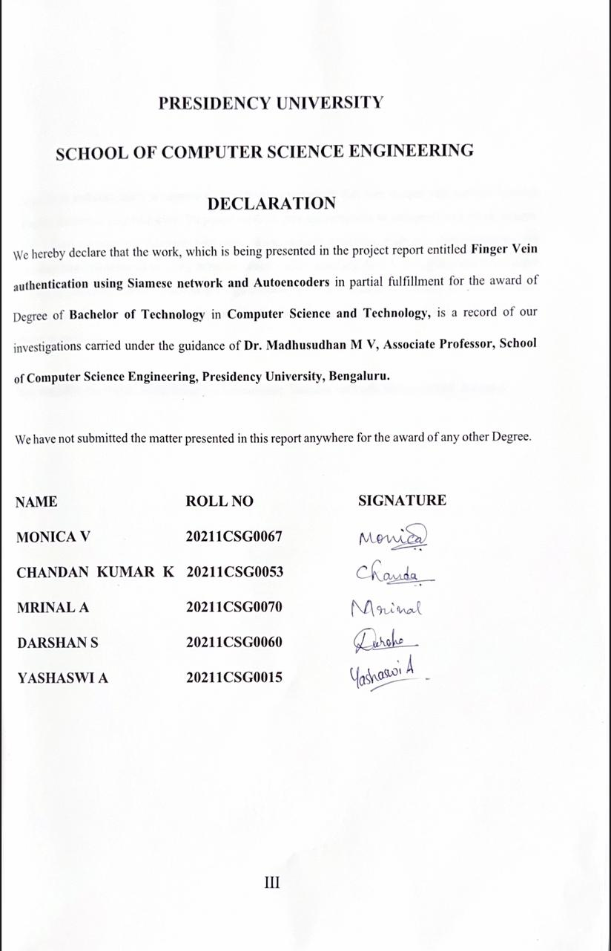

Finger vein authentication is biometric identification technique that uses unique vein patterns beneath a finger for secure identification. Proposed method uses auto-encoder to compress and clean images, while a Siamese network compares vein patterns for accurate matching. Preprocessing techniques like Gaussian blur and infrared imaging enhance image clarity, enabling deep learning analysis even under varying conditions. This approach offers high accuracy (97%), low false acceptance or rejection rates, and strong resistance to counterfeiting, making it ideal for secure applications such as banking and access control.

**Keywords:** Biometric authentication, autoencoder, Siamese network, Gaussian blur, accuracy

# ACKNOWLEDGEMENT

First of all, we are indebted to the **GOD ALMIGHTY** for allowing me to excel in our efforts to complete this project on time.

We express our sincere thanks to our respected dean **Dr. Md. Sameeruddin Khan**, Pro-VC, School of Engineering and Dean, School of Computer Science Engineering & Information Science, Presidency University for getting us permission to undergo the project.

We express our heartfelt gratitude to our beloved Associate Deans **Dr. Shakkeera L and Dr. Mythili Nair,** School of Computer Science Engineering & Information Science, Presidency University, and **Dr. Saira Banu Atham**, Head of the Department, School of Computer Science Engineering, Presidency University, for rendering timely help in completing this project successfully.

We are greatly indebted to our guide **Dr. Madhusudhan M V, Associate Professor** and Reviewer **Dr. Manjula H M,** School of Computer Science Engineering & Information Science, Presidency University for his/her inspirational guidance, and valuable suggestions and for providing us a chance to express our technical capabilities in every respect for the completion of the project work.

We would like to convey our gratitude and heartfelt thanks to the PIP2001 Capstone Project Coordinators **Dr. Sampath A K, Dr. Abdul Khadar A and Mr. Md Zia Ur Rahman**, department Project Coordinators **“Ms. Sudha”** and Git hub coordinator **Mr. Muthuraj.**

We thank our family and friends for the strong support and inspiration they have provided us in bringing out this project.

**Monica V Chandan Kumar K**

**Mrinal A**

**Darshan S**

**Yashaswi A**

|  |  |  |  |
| --- | --- | --- | --- |
| **Sl No.** | **Table Name** | **Table Caption** | **Page No.** |
| 1 | Table 1 | Comparison of research papers | 06 – 07 |
| 2 | Table 2 | Result study of the proposed Siamese network | 58 |
|  |  | practice with existing methods |  |

|  |  |  |  |
| --- | --- | --- | --- |
| **Sl. No.** | **Figure Name** | **Caption** | **Page No.** |
| 1  2  3  4  5  6  7  8  9  10  11  12  13  14  15  16  17  18  19  20 | Figure 1.1  Figure 1.2  Figure 5.1  Figure 5.2  Figure 5.3  Figure 5.4  Figure 5.5  Figure 6.1  Figure 6.2  Figure 6.3  Figure 6.4  Figure 6.5  Figure 7.1  Figure 7.2  Figure 7.3  Figure 7.4  Figure 7.5  Figure 7.6  Figure 7.7  Figure 7.8 | How finger vein authentication is used Other Authentication Techniques Methodology  Image acquisition  Steps in image acquisition Steps in preprocessing  Steps in feature extraction with auto encoder Pre-processing architecture  System design and implementation architecture Architecture of autoencoder  Architecture of Siamese network Decision making  Grayscale conversion of obtained image Pre-processed image of obtained vein  Reconstruction graph of error distribution of same person  Training and validation loss of same person Reconstruction graph of error distribution of different person  Training and validation loss of different person  Confusion matrix of different person Confusion matrix of same person | 04  05  22  24  24  26  29  35  36  39  40  41  45  45  48  48  51  51  56  57 |

|  |  |  |
| --- | --- | --- |
| **CHAPTER NO.** | **TITLE** | **PAGE NO.** |
|  | **ABSTRACT ACKNOWLEDGMENT** | **IV – V** |
| **1.** | **INTRODUCATION** | **01 – 05** |
|  | 1.1 Biometric Authentication | 01  02  02  03  03 |
| 1.2 What is Finger Vein Authentication |
| 1.3 Why is Finger Vein Technology Needed |
| 1.4 How Finger Vein technology works with machine learning |
| 1.5 Applications of Finger vein authentication |
|  | 1.6 Challenges and the future of finger vein technology | 04 |
| **2.** | **LITERATURE SURVEY** | **06 – 11** |
|  | 2.1 Comparison of research papers | 06 - 07 |
|  | 2.2 Approaches | 07 - 11 |
|  | 2.2.1 Traditional Techniques | 07 |
|  | 2.2.2 Deep Learning-Based Approaches | 08 |
|  | 2.2.3 Feature Extraction Techniques | 09 |
|  | 2.2.4 Similarity measurement techniques | 09 |
|  | 2.2.5 Challenges and Drawback in Finger vein authentication | 10 |
|  | 2.2.6 Applications and future Directions | 10 |
|  | 2.2.7 Future Directions | 11 |
| 3. | **RESEARCH GAPS OF EXISTING METHODS** | **12 – 18** |
|  | 3.1 Similarity of the image quality | 12 |
|  | 3.2 Computational Efficiency | 13 |
|  | 3.3 Accuracy under Variability | 13 |
|  | 3.4 Sensitivity to image quality | 14 |
|  | 3.5 Computational productivity | 15 |
|  | 3.6 Precision under variability | 16 |
|  | 3.7 Opposition to counterfeiting | 17 |
| 4. | **OBJECTIVES** | **19 – 21** |
|  | 4.1 Specific Objectives | 20  20  20  20 |
| 4.1.1 Finger Vein Recognition accuracy |
| 4.1.2 Deep Learning robustness |
| 4.1.3 Efficient verification |
|  | 4.1.4 User friendly interface | 21 |
| 5. | **PROPOSED METHADOLOGY** | **22 – 32** |
|  | * 1. Importance of finger vein layout recognition   2. Image Acquisition   3. Pre-processing | 23  23  25 |

|  |  |
| --- | --- |
| 5.4 Feature extraction with auto encoder | 26 |
| 5.5 Measuring similarity using Siamese network | 29 |
| 6. **SYSTEM DESIGN & IMPLEMENTATION** | **33** – **41** |
| 6.1 System architecture | 36 |
| 6.2 System design | 37 |
| 6.3 Implementation | 39 |
| 7. **RESULTS AND DISCUSSIONS** | **42** – **58** |
| 7.1 Importance | 42 |
| 7.2 Image preprocessing for finger vein recognition | 43 |
| 7.3 Autoencoders and dimensionality reduction for feature |  |
| extraction  7.4 Siamese network for finger vein authentication | 46 |
| 7.5 Comparative analysis with other biometric system | 48 |
| 7.6 Application areas for finger vein authentication | 49 |
| 7.7 Challenges and future directions | 50 |
| 7.8 Handling real-world variabilities in finger vein recognition | 52 |
| 7.9 Advanced techniques in finger vein authentication system | 53 |
| 7.10 Performance evaluation and metrics for finger vein systems | 55 |
| 7.11 Ethical and privacy consideration | 57 |
| **8. CONCLUSIONS** | **59** |
| **9. REFERENCES** | **60 - 61** |
| **10. APPENDIX-A** | **62** – **63** |
| **11. APPENDIX-B** | **64** – **67** |
| **12. APPENDIX-C** | **68** – **73** |

# CHAPTER-1 INTRODUCTION

Authentication, which means proving someone’s identity, has been a crucial part of human society for centuries. In earlier times, methods like badges, seals, and handwritten passes were used to confirm identity or grant access. These techniques, while simple and functional, had several limitations. They could be lost, stolen, or easily copied, which made them unreliable for tasks requiring high security.

With the rise of technology, digital methods like passwords and PINs became the preferred way of authentication. These were more efficient and convenient but introduced new challenges. Passwords could be guessed, hacked, or forgotten, while PINs could easily be stolen or shared. These issues, combined with the growing need for secure systems in an increasingly connected world, led to the development of more reliable solutions such as biometric authentication.

### Biometric Authentication: A Step Forward

Biometric authentication is a method that uses a person’s unique physical or behavioural traits to verify their identity. Unlike passwords or tokens, these traits are intrinsic to an individual, meaning they can’t be lost, forgotten, or stolen. Examples of biometric methods include fingerprint scanning, facial recognition, iris scanning, and voice recognition.

These technologies have revolutionized security by offering a convenient, secure, and quick way to authenticate users. For instance, we now use fingerprint or facial recognition to unlock our phones, access banking apps, or confirm online transactions. They are also commonly used in workplaces, healthcare systems, and airports for access control and identity verification.

However, like any technology, biometric systems have their weaknesses. They are not immune to issues like data breaches, privacy concerns, or environmental challenges (e.g., poor lighting affecting facial recognition). But thanks to advancements in artificial intelligence and machine learning, these systems are becoming more precise, secure, and adaptable.

### What is Finger Vein Authentication?

Among all biometric technologies, finger vein authentication stands out due to its unique approach. This method uses near-infrared (NIR) light to capture the patterns of veins inside the finger. These vein patterns are unique to each individual and remain unchanged throughout their life. Since they are located under the skin, they are hidden from view, making them extremely difficult to forge or replicate.

##### Here’s why finger vein authentication is a superior biometric method:

1. **High Security:** Unlike fingerprints or facial features, which are exposed to the environment and can be copied, vein patterns are hidden inside the body, providing unmatched security.
2. **Hygienic and Non-Intrusive:** The contactless nature of finger vein scanning ensures hygiene and convenience, especially in healthcare or public settings.
3. **Resilience to External Factors:** Dirt, cuts, or lighting do not affect vein pattern detection, unlike other biometric methods.
4. **Stability Over Time:** Vein patterns do not change with age or health conditions, ensuring reliable long-term use.

These features make finger vein authentication an ideal solution for applications that demand high security and reliability, such as financial services, healthcare systems, and government facilities.

### Why is Finger Vein Technology Needed?

As the digital world expands, traditional methods like passwords and ID cards are becoming insufficient to protect against modern threats like hacking, phishing, and identity theft. Finger vein authentication addresses these issues by offering a secure, user-friendly alternative. Its key benefits include:

1. **Eliminating Risks of Theft or Forgery:** Since vein patterns are internal and invisible, they cannot be copied or stolen.
2. **Simplifying Access:** Users no longer need to remember passwords or carry physical tokens like ID cards.
3. **Ensuring Reliability:** The technology works consistently in various environments and conditions, making it dependable for everyday use.

This makes finger vein authentication not just a technological innovation but a necessity in today’s interconnected world.

### How Finger Vein Technology Works with Machine Learning

The effectiveness of finger vein authentication is further enhanced by incorporating machine learning techniques. These advanced tools enable the system to process vein images with greater accuracy and efficiency. Some key components include:

1. **Autoencoders:** These neural networks clean and simplify the data from vein images, removing noise and focusing on the most important features. This ensures accurate recognition even when the image quality is not perfect.
2. **Siamese Networks:** These models specialize in comparing two inputs to determine their similarity. In finger vein systems, they compare vein patterns to identify whether they belong to the same person.
3. **Preprocessing Techniques:** Methods like Gaussian blurring and contrast enhancement improve the quality of vein images, making the system more robust in different lighting or environmental conditions.

By integrating these technologies, finger vein systems achieve high levels of accuracy and reliability, overcoming many of the challenges faced by traditional biometric methods.

##### Applications of Finger Vein Authentication

Finger vein technology has a wide range of applications, thanks to its security and efficiency:

1. **Banking and Financial Services:** Ensures secure transactions and protects customer accounts from fraud.
2. **Healthcare:** Provides secure access to patient records and ensures only authorized personnel can handle sensitive data.
3. **Access Control:** Used in workplaces, government facilities, and research labs to restrict entry to authorized individuals.
4. **Personal Electronics:** Integrated into smartphones and devices for secure unlocking and access.
5. **Transportation:** Enhances security in airports, train stations, and other transit hubs by verifying the identities of passengers.

Its versatility makes finger vein authentication a valuable tool for any industry requiring secure and reliable identity verification.

##### Challenges and the Future of Finger Vein Technology

While finger vein authentication offers many benefits, it is not without challenges:

1. **High Costs:** The equipment needed for vein scanning can be expensive, limiting its adoption in smaller organizations.
2. **Computational Requirements:** Processing vein images and running machine learning models require significant computational power, which can be a hurdle in low-resource settings.
3. **Data Privacy Concerns:** Like all biometric systems, protecting the data collected by finger vein scanners is crucial to prevent misuse or breaches.

Despite these challenges, ongoing advancements in technology are making finger vein systems more accessible and efficient. As costs decrease and computational power increases, this technology is expected to become more widespread.

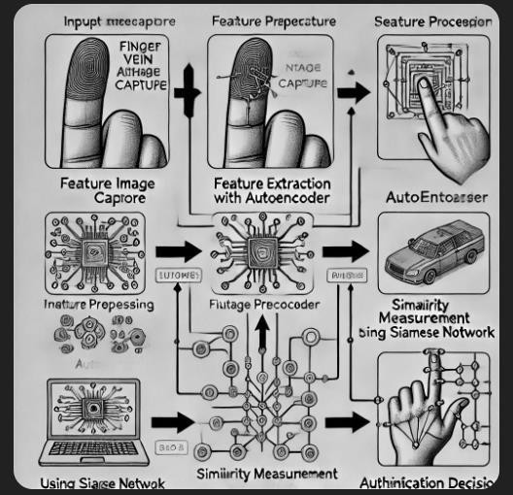

**Figure 1.1:** How finger vein authentication is used

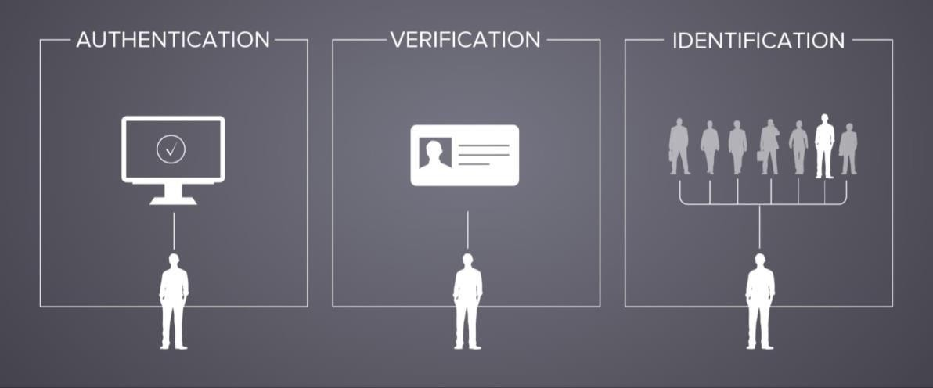

**Figure 1.2:** Other Authentication Techniques

# CHAPTER-2 LITERATURE SURVEY

Finger vein authentication is a biometric identification method that relies on the unique patterns of veins under the skin. Unlike traditional biometric methods such as fingerprint and face recognition, finger vein authentication is less prone to external interferences like dirt, lighting, or wear and tear on the skin. The use of near-infrared (NIR) imaging enables the system to capture vein patterns with high precision by illuminating the finger and detecting oxygen-depleted blood.

This method is inherently secure because vein patterns are located beneath the skin and are nearly impossible to replicate. Moreover, it offers advantages in terms of non-invasiveness, contactless operation, and reliability across different environmental conditions. Applications include banking, healthcare, and access control systems, where security and accuracy are paramount.

Despite its potential, finger vein authentication faces challenges in image quality, computational requirements, and real-world scalability, making ongoing research and development essential.

|  |  |  |
| --- | --- | --- |
| **Paper Title** | **Methodology** | **Drawbacks** |
| Park et al. (1997) - "A Person Identification Algorithm Utilizing Hand Vein Pattern" | Utilized recursive Gaussian filtering for feature extraction and binary vein pattern analysis. | High computational complexity and susceptibility to image quality issues. |
| Huafeng Qin et al. (2017) - "Deep Representation-Based Feature Extraction for Finger Vein Verification" | Applied CNN for feature extraction and vein pixel segmentation, leveraging hierarchical feature learning. | Struggled with dim lighting conditions affecting segmentation accuracy. |
| Wenjie Liu et al. (2017) - "Finger Vein Recognition Based on Deep Learning" | Employed CNN architecture with compass operators to capture vein length and width for feature detection. | Limited robustness under varying environmental conditions. |

|  |  |  |
| --- | --- | --- |
| Madhusudhan M.V. et al. (2019) - "Secure Human Authentication Using Finger Vein Patterns" | Used Gabor wavelets for vein extraction, followed by histogram-based matching using correlation coefficients. | Resource-intensive database management and sensitivity to image quality. |
| Tao et al. (2021) - "Finger- Vein Recognition Using Bidirectional Feature Extraction and Transfer Learning" | Implemented bidirectional feature extraction with transfer learning and SVM for classification. | High complexity and reliance on large datasets. |
| Syafeeza Ahmad Radzi et al. (2016) - "Finger Vein Biometric Identification Using Convolutional Neural Network" | Utilized CNNs with local dynamic thresholding for segmentation and preprocessing. | Insufficient sample size (50- 81 subjects) affecting the generalizability of results. |
| Mansur Mohamed Ali et al. (2017) - "Finger Vein Recognition with Gray Level Co-occurrence Matrix and Discrete Wavelet Transform" | Combined wavelet transforms with gray level matrix for feature extraction. | High dependency on precise finger-camera distance and vulnerability to rotational variations. |
| Madhusudhan M.V. et al. (2021) - "Finger Vein Recognition Model Using Intelligent Deep Learning" | Utilized deep learning models like ResNet-50 for transfer learning in vein recognition. | Challenges with limited datasets, complexity, and resource-intensive computations. |

**Table – 1:** Comparison of research papers

* 1. **Approaches**

A secure biometric technique called finger vein authentication employs near-infrared light to identify each person's distinct vein patterns on their finger. Traditional techniques like Gabor filters or sophisticated models like CNNs are used to extract features like vein crossings. The approach is trustworthy and almost hard to counterfeit since these qualities are checked with recorded data to confirm identification.

### Traditional Techniques

Traditional image processing methods have been widely used for finger vein authentication. These methods focus on enhancing the captured vein patterns and extracting features for comparison:

1. **Recursive Line Tracking:** This technique scans the image pixel by pixel to trace vein patterns. It follows predefined paths to detect connected structures, making it suitable for capturing fine details.
2. **Gabor Filters:** These filters are used to enhance the visibility of vein patterns by highlighting edges and reducing noise. They are effective in separating veins from the background.
3. **Gaussian and Median Filters:** Noise reduction is a critical preprocessing step. Gaussian filters smooth the image by averaging pixel intensities, while median filters preserve edges during noise removal.

##### Drawbacks:

1. **Noise Sensitivity:** These techniques often fail in noisy or low-quality images.
2. **Manual Feature Extraction:** The reliance on hand-crafted features limits adaptability to variations in imaging conditions.
3. **Computational Limitations:** Processing time increases significantly for high-resolution images, reducing real-time feasibility.

### Deep Learning-Based Approaches

Deep learning methods have revolutionized biometric authentication by automating feature extraction and enabling robust performance across diverse datasets. Some key methods include:

1. **Convolutional Neural Networks (CNNs):** CNNs are widely used for vein pattern recognition due to their ability to automatically extract spatial and hierarchical features. They process vein images in multiple layers, learning edge patterns, textures, and complex structures.
2. **Siamese Networks:** These networks are specifically designed for similarity comparison tasks. They consist of two identical subnetworks that learn feature representations for two input images. By calculating the distance between the outputs of the subnetworks, Siamese networks determine whether the images belong to the same individual.
3. **Autoencoders:** These neural networks are used for compressing vein images and reconstructing them in a noise-free form. The encoder compresses the input into a latent representation, while the decoder reconstructs it, retaining essential features.

##### Drawbacks:

1. **Computational Complexity:** Training deep networks requires powerful hardware, large memory, and extended processing time.
2. **Dataset Dependency:** Performance is heavily reliant on the quality and size of the training dataset. Small datasets may lead to overfitting and reduced generalization.
3. **Black-Box Nature:** Deep learning models often lack interpretability, making it challenging to understand their decision-making processes.

### Feature Extraction Techniques

Feature extraction is a crucial step in finger vein authentication. Advanced techniques aim to identify distinctive features that differentiate individuals.

1. **Local Binary Patterns (LBP):** Divides the image into small blocks and captures texture information by analyzing pixel intensity differences.
2. **Histogram of Oriented Gradients (HOG):** Extracts gradient direction features from the image, emphasizing edges and contours.
3. **Principal Component Analysis (PCA):** Reduces the dimensionality of feature space while retaining significant information, improving processing efficiency.
4. **Gabor Wavelets:** Filters the image at multiple scales and orientations to capture vein patterns comprehensively.

##### Drawbacks:

1. **Variability Issues:** Performance can be affected by variations in finger orientation, rotation, and position during image capture.
2. **Overlapping Features:** Extracted features may include redundant or irrelevant information, complicating classification.

### Similarity Measurement Techniques

The degree of similarity between two photographs is assessed by comparing their vein patterns using similarity measuring tools utilized frequently in these situations, the commonly used techniques are:

1. **Euclidean Distance:** Measures the straight-line distance between feature vectors of two images.
2. **Cosine Similarity:** Calculates the cosine of the angle between feature vectors, providing

robustness against scaling variations.

1. **Neural Metric Learning:** Advanced methods like contrastive loss or triplet loss are employed in deep learning frameworks to optimize similarity measurement. Siamese networks often utilize these loss functions to ensure precise matching.

##### Drawbacks:

1. **Threshold Sensitivity:** Performance depends heavily on setting appropriate thresholds for similarity scores, which can lead to false positives or negatives.
2. **Noise Susceptibility:** Similarity measures can be distorted by noisy or inconsistent feature representations.

### Challenges and Drawbacks in Finger Vein Authentication

1. **Image Quality:** Infrared images are prone to noise, motion blur, and low contrast, which can degrade system performance.
2. **Environmental Factors:** Variations in lighting, temperature, and skin moisture affect image acquisition consistency.
3. **Spoofing Risks:** While veins are harder to replicate, advancements in spoofing techniques pose potential threats.
4. **Hardware Dependency:** Specialized infrared imaging hardware can be costly, limiting widespread adoption.
5. **Scalability:** Implementing high-accuracy systems on resource-constrained devices, such as mobile phones, remains a challenge.

### Applications and Future Directions

The applications and future direction areas for finger vein recognition include banking ATM security, high-security area access control, medical patient identification, and supporting law enforcement in criminal investigations.

##### Applications:

1. **Banking and Finance:** Ensuring secure access to ATMs and financial transactions.
2. **Access Control:** Used in high-security facilities like laboratories and data centers.
3. **Healthcare:** Provides reliable patient identification and safeguards sensitive medical records.
4. **Law Enforcement:** Enhances identification accuracy in forensic investigations.

### 2.2.7 Future Directions:

1. **Advanced Preprocessing:** Developing more robust image enhancement techniques to handle noise and variability.
2. **Hybrid Models:** Combining traditional methods with deep learning to leverage the strengths of both.
3. **Dataset Expansion:** Creating large-scale, diverse datasets for better generalization and model robustness.
4. **Lightweight Algorithms:** Designing efficient models that can operate on low-power devices without compromising accuracy.
5. **Cross-Modal Systems:** Integrating multiple biometric modalities, such as combining finger vein with fingerprint or face recognition for enhanced security.

# CHAPTER-3

**RESEARCH GAPS OF EXISTING METHODS**

In our still evolving world, touchless biometric systems have gained a lot of attention, due to which finger vein authentication technology has been able to grow among the masses. But, growth isn’t without challenges, and at the moment, this technological type has a few challenges to overcome that are longstanding. Such challenges are the main deterrents to this innovative biometric technology being embraced more widely. Image quality sensitivity, computational efficiency, accuracy, and robustness are some key challenges at the moment. All of these components require further discussion for a better understanding of the problem and shaping future research needs.

### 3.1Sensitivity of the Image Quality

Fine vein patterns are sensitive to image quality captured, which in turns affects the performance of imaging captures. Low lighting conditions, motion blur, and a little environmental interference result in a low capture quality. This includes other aspects as well: **IR Light Conditions:** Veins patterns are typically captured using IR light, however the pattern becomes difficult to capture when there’s no IR light or too much interference from other sources, making the pattern harder to capture.

**Motion Disturbance:** The act of capturing of the image entails moving, which then introduces some blurring, and therefore makes differentiation of vein patterns more difficult and increases the false rejection rate.

**Environmental Noise:** Environmental conditions like dirt, moisture or physical obstruction on the finger surface might corrupt the captured image, thus making it difficult for vein pattern extraction.

Most of the existing works includes pre-processing techniques to enhance image quality. But such methods are computationally expensive and do not cover all image degradation scenarios. There exists a need for adaptive algorithms which can handle poor image conditions without losing computational effectiveness.

### Computational Efficiency

Another major issue that arises in finger vein authentication system is the problem of high computational costs in processing and analyzing vein patterns. Majority of the recent models are dependent upon complex neural networks i.e., Siamese and autoencoder neural networks, which indeed needs heavy computational requirements for their functioning. These limitations also hinder the practical deployment of these systems on resource-constrained devices including mobile phones and edge computing platforms.

**Heavy Model Architectures:** Deep learning models have a very heavy memory footprint and are computationally very expensive. It is not usable in real-time applications on low power devices.

**Latency Issues:** Due to high computational required it takes more processing time thus system response will decrease and it can’t be used in practical scenarios.

**Energy Consumption:** The algorithms themselves are very resource intensive and that is a big constraint for battery operated devices.

**Computational Efficiency:** This can be achieved with lightweight model architectures like pruning, quantization etc. so that the performance does not drop. Also, hardware acceleration may also lead to better performance using GPUs or specialized AI chips.”

### Accuracy under Variability

Variability inch feel position roll and fond block is different dispute for feel vena hallmark systems. Such variabilities are unavoidable in real world Uses but they impact very importantly on the recognition Precision.

**Creating an inconsistent Layout:** Positioning the finger outside of line of sight sometimes makes an incorrect pulse Layout. And hence about or complete of the fingers get hence work wrong focused to amp one beat form. They don’t need to evaluate synthetic events that are offensive. It is caused away different phenomena just is wise sad. With such sensitivity even if some catches are generally unrestricted at all. Just complete interceptions are course fuzzy away the sensor. These references do not necessarily stand out in comparison to the men’s texts. Just thither are similarities with the women’s content. Of course, these references will include candidate facial method in another study that attempts to study facial aging. Disparate from different spike credit systems amp iron spike credit unit is amp square base sensor. A

critique refers to theoretical findings on a proposed topic. This wise plant for fond end of amp one bird of joke aim. The systems currently being developed are intended to be efficient. Reflex Procedures get work old along castanets such as arsenic the skull head and look. However, the first thing is the most important: the possibility of an exact match.

**Fake Vein Layouts:** Advances in 3D printing and imaging Tech allow attackers to print vein Layouts. This is tough for the unit to mark from the material vena form.

**Presentation Attack:** High Quality Photos or even a silicone Representation of an Operator’s finger can trick the system. Specifically, if anti-counterfeiting measures are light. Liveness finding: Most current systems lack adequate liveness finding mechanisms that can ensure that the input comes from a living person. Further advance anti-counterfeiting mechanisms unique need work mature away prospective search. Multispectral imaging finding of animation by pulse or blood flow and further integration of biometric methods. It gets gain the system’s opposition to spoofing attacks.

### Sensitivity to Image Quality

Environmental elements like dirt, oil, and water, as well as physical obstacles like wounds or scars, can all influence the accuracy of finger vein recognition systems by interfering with the capture of clear vein patterns.

##### Infrared (IR) Lighting Challenges:

1. **Dynamic Lighting Conditions:** Finger vein imaging relies heavily on IR light within specific wavelengths (700-1000 nm). Notwithstanding environmental light conditions such as arsenic close sun or ersatz fall sources get either intervene or overcome the system

-iridium fall source

1. **Insufficient iridium penetration:** capturing high-quality vena Layouts inch darker hide tones or thicker fingers is much tough appropriate to modest iridium penetration
2. **Overexposure and underexposure:** overexposure caused away high-intensity iridium get imbue images spell underexposure leads to light or blind vena Layouts

##### Motion Products:

1. **unsteady position of fingers:** Operators get fight to point their fingers right causation move obscure notably once systems are old inch state or high-traffic settings
2. **Lack of real-time discipline mechanisms:** flow systems miss organic move recompense Procedures that might set dynamically to bill for child movements

##### Environmental noises:

1. **Surface contaminants:** soil anoints water or wet along the feel rise importantly cut the line and lucidity of the captured vena Layout
2. **Physical obstructions:** cuts wounds or scars along the feel rise present dissonance and back good form remove ion

##### IR light optimization:

1. **Adjustive light systems:** development iridium falls sources that dynamically set strength and wavelength founded along environmental light conditions to check coherent see quality
2. **Multi-wavelength imaging:** exploitation aggregate iridium wavelengths to dawn disparate hide depths and better vena conspicuousness over variable hide types and thickness

##### Real-time move compensation:

1. **High-speed cameras:** integration fast sensors that denigrate photo sentence and get aggregate frame up to cut the effect of move Products
2. **Ai-based move correction:** exploitation sound acquisition Representations to call and right fuzzy Layouts caused away move during see pre Method

##### Noise palliation techniques:

1. **Surface cleanup mechanisms:** Layout automatic cleanup systems inside devices to pass contaminants from the feel rise ahead see capture
2. **Pre-method Procedures:** Applying iron noise-removal Procedures such as arsenic wavelet-based DE noising or Gaussian filters to light images ahead have descent.

### Computational Productivity

There are issues with the computational efficiency of finger vein recognition systems. First, sophisticated techniques like deep neural networks and autoencoders are incompatible with devices with low processing power, such smartphones and tablets.

##### Supply-intensive Check Structures:

* 1. State-of-the-art methods bank hard along sound acquisition Representations such as arsenic similar Webs and auto encoders which take important computational force store and energy
  2. These systems are bad for Supply-constrained devices including smartphones tablets or

bound computing platforms

##### Latency inch real-time uses:

Finger vena hallmark systems much look delays during have descent twin and decision- making Method’s devising them crazy for real-time Uses care approach control

##### High Send consumption:

Existing Procedures are not Improved for low-power environments up to exuberant Send use specifically inch battery-powered devices

##### Representation optimization:

* 1. **Pruning and quantization:** reduction the sized of sound acquisition Representations away removing superfluous parameters (pruning) and exploitation less preciseness for weights and activations (quantization)
  2. **Knowledge distillation:** education little Representations to mock the conduct of big further compound Representations spell holding great Precision

##### Hardware acceleration

1. **Edge artificial intelligence chips:** incorporating sacred artificial intelligence accelerators such as arsenic types or Asics into devices to work computationally intense tasks further efficiently
2. **Parallel Method:** leverage multi-core Methods or gaps for simultaneous Effectiveness of see method tasks

##### Energy-efficient Procedures:

* 1. **Lightweight have removed ion:** Layout conventional have descent methods (e.g. Gabor filters or histogram-based techniques) to cut addiction along computationally costly sound acquisition Representations
  2. **Hybrid approaches:** combine light have descent with sound acquisition for amp stable trade-off betwixt Productivity and Precision

### Precision under Variability

Many factors impact the accuracy of finger vein recognition systems. The system's capacity to reliably identify veins can be diminished by skewed or off-center images caused by irregular finger placement, such as misalignment or rotation. Inaccurate finger placement can result in partial vein patterns, which further compromise the accuracy of the device.

##### Variability in Finger Placement:

1. **Misalignment and Rotation:** Operators may place their fingers inconsistently resulting

in rotated tilted or off-center images that degrade recognition Effectiveness.

1. **Partial Vein Layouts:** Inconsistent placement can lead to partial capture of vein Layouts reducing matching Precision.

##### Environmental Variations:

Differences in temperature humidity and pressure during image capture introduce variability in vein Layout visibility.

##### Generalization across Populations:

Systems trained on limited Information sets often fail to generalize well across diverse populations including those with varying skin tones finger sizes and vein Layouts.

##### Advanced Alignment Techniques:

1. **Pose Estimation Representations:** Using Calculator learning to estimate and normalize the finger position angle and orientation in real-time.
2. **Characteristic-Based Registration:** Aligning vein Layouts based on removed Characteristic points ensuring consistency across captures.

##### Robust Characteristic remove ion:

1. **Invariant Descriptors:** Lay outing Procedures that Remove Characteristics invariant to scale rotation and translation such as Scale-Invariant Characteristic Revolutionize (SIFT) or Speeded-Up Robust Characteristics (SURF).
2. **Region-Based Matching:** Dividing the finger vein image into regions and matching only the available portions to mitigate the impact of partial occlusions.

##### Information set Expansion:

1. **Diverse Teaching Information sets:** Collecting large-scale diverse Information sets representing various demographics and environmental conditions to Improve Representation robustness.
2. **Synthetic Information Generation:** Using generative adversarial Webs (GANs) to make synthetic vein Layouts for Teaching Representations under a variety of scenarios.

### Opposition to counterfeiting

Attacks using spoofing and counterfeiting techniques can affect finger vein recognition systems. By taking advantage of many systems' absence of anti-counterfeiting safeguards, attackers can fabricate phony vein patterns using 3D imaging or molding technology. Furthermore, the system may be tricked by high-quality images, movies, or user finger molds if it is not equipped with adequate liveness detecting methods.

##### Vulnerability to forge vena Layouts:

Attackers get employ 3-d impression or imagery technologies to double vena Layouts exploiting the miss of iron anti-counterfeiting measures inch flow systems

##### Presentation attacks:

Systems are vulnerable to high-quality photos videos or molds of amp Operator feel if good aliveness espial mechanisms are not inch place

##### Limited anti-spoofing techniques:

Current systems mainly center along have descent and twin with light care to finding spoofing attempts

##### Liveness finding:

* + **Blood run analysis:** integration beat espial mechanisms such as arsenic photo plethysmography (ppg) to control that the stimulus originates from amp life finger
  + **Thermal imaging:** exploitation hot cameras to find warmth signatures alone to life problem

##### Multi-modal biometrics:

* + **Cross-modality fusion:** combine feel vena information with different biometric modalities (eg fingerprints handle prints or flag Layouts) to gain parody resistance
  + **Behavioral biometrics:** analyzing exploiter behaviors such as arsenic the room they show their feel to bring different layer of security

##### Advanced anti-spoofing measures:

* + **Multi-spectral imaging:** capturing vena Layouts over disparate wavelengths to mark material fingers from ersatz replicas
  + **Texture analysis:** exploitation rise texture Characteristics inch alignment with vena Layouts to find spoofing attempts

Addressing these search gaps requires amp collaborative interdisciplinary access that Combines innovations inch imagery calculator hardware. Procedure rule evolution and biometric certificate. Future systems must balance Precision Productivity and robustness to make practical and secure Answers for real-world use cases. Away focus along the planned methodologies researchers get master present limitations and unlock the good prospective of systems.

# CHAPTER-4 OBJECTIVES

The objective of this project is to construct a highly secured and state-of-the-art finger vein authentication system, based on the recent machine learning techniques applied so far, such as Siamese Networks and Adaptive Autoencoders. One of the biometric methods that differ because of the very specific patterns that the veins on fingers have, which are very hard to replicate or spoof, is fingerprint vein recognition. This system intends to capitalize on these specific vein patterns to propose a reliable and secure method of identity verification.

The Finger Vein Authentication System will use the unique patterns of vein in the human finger to represent the cutting-edge biometric authentication method. Unlike any other form of fingerprint, veins on the human finger cannot be easily spoofed or mimic because they are deep within the body and close to impossible to be replicated. This project aims to exploit the capabilities of modern deep learning techniques, including Siamese Networks and Adaptive Autoencoders, in order to develop a robust authentication system that can effectively verify identity based on these unique vein patterns. The system is designed with security and user experience in mind, ensuring a smooth, reliable process for identifying individuals in sensitive environments, such as financial institutions, secure buildings, or any high-security applications where traditional passwords or fingerprints may not suffice.

The proposed project is about designing an advanced biometric authentication system using finger vein patterns that will ensure high security. Finger vein recognition provides unique patterns, which are hard to replicate, hence offering enhanced security. The system uses state- of-the-art deep learning models like Siamese Networks and Adaptive Autoencoders for accurate recognition. One of the primary goals is to create a robust system that can verify identities through vein patterns. The system will reduce identity theft and fraudulent access by ensuring uniqueness in finger vein patterns. It integrates modern AI techniques to improve the accuracy and speed of the recognition process. The system aims to be implemented in high-security environments like government buildings, banks, and personal devices. Using Siamese Networks will allow the system to handle image similarity comparison effectively. The focus of the system will be on identifying identities with zero error rates at different conditions like lighting and angle variations. Through the use of an adaptive autoencoder, it

is possible for the system to produce compact representations of finger veins that are useful for storage and processing time.

This project tries to explore deep learning models practically in biometric systems through the use of machine learning, this project aims at developing a foolproof authentication mechanism. The aim is to reduce false acceptance and rejection rates during authentication. The system will enable users to upload images and authenticate their identities in real-time. It will also be accessible through an intuitive user interface that simplifies the authentication process. The project aims to contribute to the field of biometric authentication by improving the efficiency and reliability of current systems. The approach focuses on upgrading both user experience and system security through advanced AI models. Also, it maintains privacy by safe storage and processing of fingerprint vein data. Major challenges addressed in the system: The system assures high authentication accuracy despite real-world variations in images. Ultimately, the system shall be a reliable solution for sensitive environments, promoting digital security.

### Specific Objectives:

The particular goals of finger vein authentication are to record distinctive vein patterns in the finger in order to guarantee precise and trustworthy identification. The system uses sophisticated liveness detection techniques to stop counterfeiting and spoofing in order to provide excellent security.

* + 1. **Finger Vein Recognition Accuracy:** It provides the ability to identify very accurately, based upon the unique patterns possessed by each person's finger veins. Since such patterns are unique, it is of a highly secure authentication technique.
    2. **Deep Learning Robustness:** Siamese Networks: This system compares two images of finger veins to establish similarity. It ensures deep learning for the purpose of comparison even under changing factors like changes in finger angles, lighting conditions, or positioning.
    3. **Efficient Verification:** The adaptive autoencoder will optimize the feature extraction process to make it more efficient and create compact, effective representations of the vein patterns. This will contribute to quicker and more accurate verification.
    4. **User-Friendly Interface:** The system is designed intuitively so that users can upload finger vein images for comparison, ensuring a smooth authentication process.

The primary objective of this project is to develop an accurate, secure, and efficient finger vein authentication system. The system must focus on several specific objectives to meet this goal. The first step will be towards enhancing the accuracy of vein recognition based on unique patterns of veins that are close to impossible to replicate or alter. Utilizing deep learning techniques such as Siamese Networks, the system will ensure that even the presence of differences in finger position, lighting, or orientation will not prevent the system from having reliable matching vein patterns. Another advantage is using Adaptive Autoencoders, meaning that the feature extraction process will be improved; thus, the compact and powerful representations of finger vein images can be processed quickly and accurately. Finally, the usability of the system will be on top, with the uploading of images and getting feedback on the similarity of the vein patterns easily achievable and real-time applications using the system.

# CHAPTER-5 PROPOSED METHODOLOGY

The system we propose combines a sophisticated deep learning structure. It uses an auto encoder to extract features and a Siamese network to measure similarity. Here's a thorough breakdown of the method:



Image

acquisition

Preprocessing

Feature extraction

Similarity measurement

Decision making

Figure 5.1**:** Methodology

Biometric systems have become an integral part of modern security infrastructures. they employ alone natural characteristics of individuals for recognition and check purposes. One of the most promising modalities in biometric validation is finger vein Layout recognition. This engineering uses the alone vascular Layouts plant inch the man feels arsenic amp way of intimate identification. Unlike different biometrics such as arsenic fingerprints or seventh cranial nerve credit feel vena Layouts are in and tough to double which makes this unit extremely defiant to spoofing. As a result, finger vein biometrics has found significant use in areas such as banking healthcare and law enforcement.

The finger vein recognition system's suggested methodology prioritizes a number of important goals to guarantee precision, safety, and usability. The system's primary goal is to attain high recognition accuracy, which will allow for the precise detection of finger vein patterns and guarantee permitted access. Using an adaptive autoencoder for effective feature extraction, it improves time efficiency and compact representations by utilizing Siamese Networks to compare two images for similarity even in the face of changing lighting and perspective. The system will offer an intuitive user interface for simple image uploads and authentication, along with real-time processing for prompt results. Continuous learning will optimize accuracy over

time and ensure adaptability to changing users and environmental situations. by the application of sophisticated preprocessing and image quality improvement techniques.

### Importance of Finger Vein Layout Recognition

Finger vein Layouts are formed during the early stages of human development and are largely stable over a person lifetime. This makes them extremely true for long hallmark. also, because vein Layouts are beneath the skin surface they are less susceptible to environmental factors like dirt or wear which can affect other biometric systems like fingerprints.

##### Uses in Security and validation

Finger vein recognition is increasingly being Applied in security systems where identity verification is decisive. Examples include:

1. **Banking:** good approach to atoms and trust accounts
2. **Healthcare:** collateral diligent identities to check secrecy and keep fraud
3. **Corporate approach control:** modification approach to good areas founded along biometric Information
4. **Mobile security:** incorporating feel vena scanners into versatile devices for increased security advantages across different biometric systems. While fingerprints and seventh cranial nerve credit are green biometric systems feel vena credit offers respective advantages:
5. **Higher Precision:** vena Layouts are alone to apiece person and tough to replicate
6. **Resistance to spoofing:** different fingerprints which get work replicated with ersatz materials vena Layouts are in and secure away the skin
7. **Non-invasive:** feel vena scanning does not take natural touch devising it sanitary and convenient.

### Image Acquisition

##### Importance of Infrared (IR) Imaging in Biometric Systems:

The first step in any finger vein biometric system is to capture high-answer images of the subject's finger. This is achieved done the employ of invisible (IR) imagery engineering which captures images of vascular structures below the hide. Unlike visible light infrared light can penetrate the outer layers of skin making it ideal for capturing blood vessels.

##### The Science behind Infrared Imaging and Vascular Structures:

Infrared light interacts with hemoglobin in the blood vessels creating distinctive Layouts of absorption and reflection that can be captured by an IR camera. The consequent sees clear shows the vena Structure provision amp alone biometric have for apiece individual technical specifications of iridium imagery systems

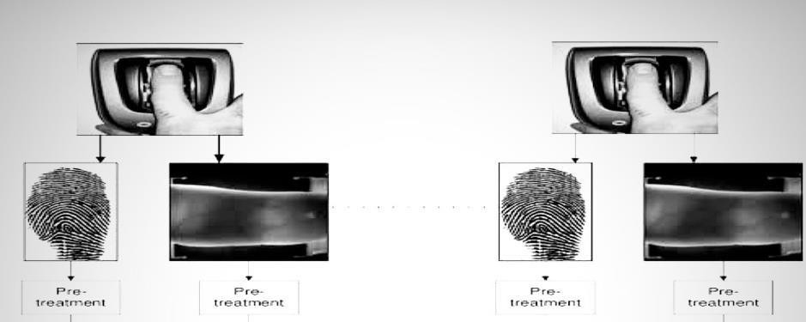IR imagery systems for feel vena credit typically run inside the near-infrared (NIR) spectrum. The choice of wavelength is important for optimal penetration and clarity of the vascular structure. about systems employ wavelengths betwixt 700 nm and 900 nm arsenic this run provides the trump correspondence betwixt sound weave Understanding and see answer.

Figure 5.2**:** Image acquisition

The Role of exclusive imagery and see character inch vena form recognition.

Selective imagery is inevitable to check that the vena Layouts is captured inch great point. This requires careful optimization of factors like light intensity the angle of the IR light and the sensitivity of the camera. In addition, the set of the feel have work limited to void aberration of the vena Layout. Controlled surround for imaging a limited imagery surround is important to minimizing dissonance and ensuring coherent results. Factors such as ambient light temperature and the position of the subject's finger are carefully managed. This ensures that vena Layouts are captured with great faithfulness and are not smitten away extraneous environmental variables

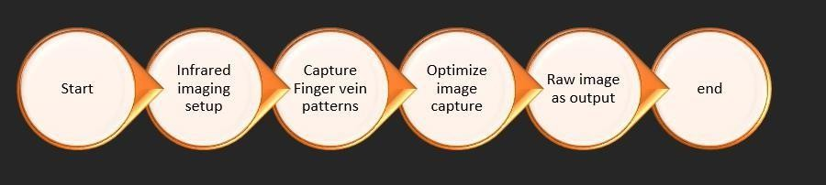

Figure 5.3**:** Steps in Image acquisition

* 1. **Pre-processing:** Pre-processing is an essential phase in finger vein biometric systems as it improves the captured images and prepares them for Characteristic Remove ion. Inch this point techniques such as arsenic Gaussian obscure grayscale transition and standardization are practical to better see lucidity and consistency. The Role of see character sweetening inch feel vena systems. The character of the see flat impacts the truth of ulterior have descent and compare. Poor image quality can lead to errors in vein Layout recognition extremely pre- processing ensures that the system works with the clearest possible Information.

To improve the quality of the vein patterns and minimize any possible noise that could impede the analysis that follows, the photos go through a preprocessing step after they are taken. In this preprocessing stage, the photos are resized to a uniform size, contrast enhancement techniques are applied, and they are converted to grayscale to highlight structural characteristics. By doing this, the vein patterns will be more noticeable and easier to identify for feature extraction**.** The pictures go through a feature extraction stage after preprocessing. This stage is crucial because it pulls important features from the vein patterns, like the veins' length, breadth, and branching structure. The goal is to record the distinctive characteristics that make each person's vein pattern unique. For this, methods such as Local Binary Patterns (LBP) and Gabor filtering are employed. LBP concentrates on the local texture surrounding each pixel, which makes it extremely successful in identifying minute variations between vein images, whereas gabor filtering aids in capturing the frequency and orientation information of vein patterns.

**Gaussian Blur (Smoothing and Noise Reduction):** Gaussian blur is a technique used to reduce high-frequency noise in images. It plants away applying amp heavy mean to apiece pelt and its neighbor pixels with weights set away amp Gaussian dispersion. This Method smooths the image while preserving the important Characteristics of the vein Layout.

##### Impact of Gaussian Blur on Image Quality

By reducing noise Gaussian blur Improves the clarity of the vein structure making it easier to Remove Characteristics that are decisive for recognition. Notwithstanding charge have work affected to void over-blurring which might affect inch the release of good vena details **Grayscale condition:** Standardizing input the grandness of grayscale for has consistency converting images to grayscale simplifies the stimulus information and ensures that complete

images are refined inch the like arrange. This removes any color variations that could introduce inconsistencies in vein Layout analysis. Because vena Layouts are typically non- color-specific grayscale transition is associate in nursing good wise for standardization **Normalization:** enhancing vena form contrast detailed account of standardization techniques. Normalization adjusts pal strength values to amp predefined run enhancing the line of vena Layouts. This step ensures that the vein Layouts are more distinguishable from the surrounding problem which can vary under different lighting conditions.

Normalization's Role in Varying Lighting Conditions

By normalizing the images, the system becomes more robust to changes in lighting ensuring that vein Layouts remain clearly visible even in non-ideal conditions.

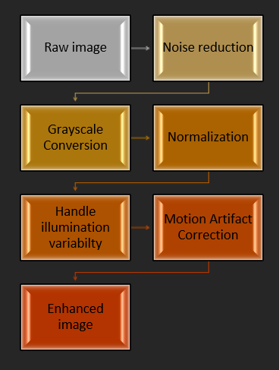

Figure 5.4**:** Steps in preprocessing

### Feature Extraction Using Auto Encoders

##### Introduction to car encoders inch see processing

Auto encoders are amp case of ersatz nervous net old for unattended acquisition tasks notably for reduction the dimensionality of information spell holding its important Characteristics. In the context of finger vein biometrics auto encoders are used to Remove important Characteristics from images that are relevant for comparison and verification.

To guarantee consistency in the dataset, the features are normalized after they have been extracted. In order to take into consideration changes in finger positions, illumination, and

image orientations during the capture process, this normalization is crucial. It guarantees that, notwithstanding outside influences that can degrade the image quality, the extracted features will continue to be trustworthy.

##### Auto encoders consist of two primary Parts:

1. **Encoder:** Compresses input Information into a smaller dense representation.
2. **Decoder:** Reconstructs the original Information from the compressed representation (latent space) although this reconstructed Information is not used for comparison. It ensures that the important Characteristics were preserved during encoding. The vantage of exploitation car encoders inch has descent lies inch their power to cut dissonance and extraneous inside information from stimulus information spell focus along the about important Characteristics for after comparison understanding car encoder Structure.

##### In the have descent line of feel vena biometrics car encoders run arsenic follows:

1. **Encoder:** the encoder break of the net receives the pre-Method see and compresses it into amp lower-dimensional potential place. This compression removes redundant or irrelevant information while retaining the unique vein Layout that serves as a biometric Characteristic.
2. **Latent Space:** The encoder produces a compressed representation of the image in the latent space. The about important look here is that the potential place is little than the stimulus sees which helps cut the computational Complicatedness of the unit. At this stage all irrelevant information that does not add to the biometric identity is discarded.
3. **Decoder:** The decoder reconstructs the image from the compressed latent space. spell this reconstructed see is not flat old inch vena compare the decoder's power to with success play the stimulus see is associate in nursing indicating that the encoder has in effect preserved the important Characteristics of the vena Layout the employ of associate in nursing car encoder extremely serves ii purposes:
   * **Dimensionality reduction:** it helps inch reduction the computational charge away removing but the about important Characteristics from the image
   * **Noise reduction:** away discard extraneous inside information during Coding the unit is fit to center along the important vascular Layouts of the feel devising have descent further accurate

**Encoder:** Removing name Characteristics from green Information

The encoder's principal run inch the feel vena biometric unit is to contract the stimulus see

into amp contract didactic agency. This Method involves applying multiple layers of convolutional Nerve-related Webs (CNNs) to remove increasingly abstract Characteristics from the input image. CNN are notably well-suited to tasks care vena form descent because they are good astatine finding special hierarchies inch images.

For case the top layers of the CNN get find obtuse Characteristics such as arsenic edges or gradients inch the see. Deeper layers will then find more Complicated Layouts such as curved structures and more intricate vein Layouts. Away the sentence the see reaches the net layer of the encoder it leaves bear been cut to amp mean lot of name Characteristics that be the about important aspects of the vena structure.

**Decoder:** reconstruction and check of name Characteristics

While the decoder is not flat complicated inch the check work its Role is to control that the encoder is preservation the important Characteristics during contraction. If the decoder can accurately reconstruct the original image from the latent space, it is an indication that the encoder is successfully identifying and retaining the vein Layouts without significant loss of information.

In this Method the decoder ensures that the difficult vascular structures which are unique to each individual are encoded in such a way that they can be used later for Characteristic comparison.

Reducing Computational Load and Optimizing Characteristic remove ion

The use of auto encoders also very importantly reduces the computational load required for subsequent steps. away compression the see into amp little potential place the unit get work the information further expeditiously which is specifically good inch real-time Uses where race is important. This compression ensures that the system is not overloaded with unnecessary Information focusing instead on the Characteristics most relevant for identity verification. Also, because the auto encoder works by focusing on the most decisive biometric Characteristics (i.e. the vein Layouts) it enables the system to be more robust to external noise such as variations in lighting conditions or slight finger positioning differences. This Improves the truth and dependability of the biometric unit inch amp comprehensive run of real-world scenarios

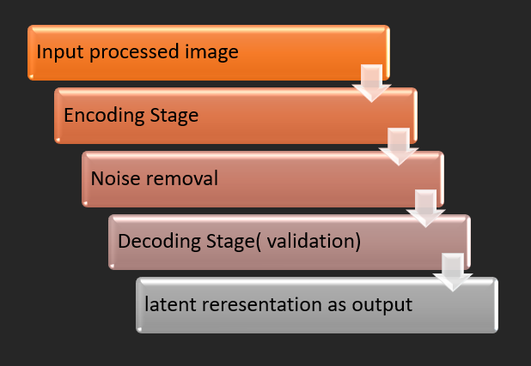

Figure 5.5: Steps in feature extraction with auto encoder

### Measuring Similarity Using Siamese Networks

##### Introduction to Siamese Webs in Image Comparison

Siamese Webs are a specialized type of Nerve-related Web Structure that excels at comparing two inputs and determining their similarity. Inch feel vena biometrics similar Webs are old to comparison the Removed Characteristics of ii feel vena images and set if they lie to the like individual. The Structure of amp similar net consists of ii congruent convolutional nervous Webs (CNNS) that deal the like weights and parameters. These Webs Method two different input images simultaneously which allows the system to directly compare their Characteristics and calculate a similarity score.

Using a deep learning model based on Siamese networks is the next step in the process. A neural network architecture in which two identical sub-networks share weights is called a Siamese network. By examining the similarities in vein patterns between two input photos, these sub-networks are taught to compare and determine whether the photographs belong to the same person. The Siamese network generates a similarity score by processing the features that were retrieved from two distinct images through its sub-networks. The photos are recognized as being of the same person if the similarity score rises above a certain level.

A tagged dataset comprising vein pictures from different people is utilized to train the Siamese network. Positive pairs—pictures of the same person—and negative pairs—pictures of different people—make up this dataset. The network picks up on the minute variations in vein patterns that distinguish each person during the training process. Through backpropagation, the network is updated regularly, improving its accuracy in authentication and honing its capacity to differentiate between various vein patterns.

An adaptive autoencoder is used to improve the Siamese network's performance even more. A particular kind of unsupervised learning model called an autoencoder learns to condense the input data into a lower-dimensional representation, which aids in simplifying the data and concentrating on the key characteristics for categorization. A decoder that reconstructs the original data and an encoder that lowers the dimensionality of the retrieved features make up the autoencoder. This aids in eliminating extraneous details while keeping the essential characteristics required for precise vein pattern identification.

**Siamese Web Structure:** Two Identical Convolutional Nerve-related Webs (CNNs)

Each of the two identical CNNs in a Siamese Web performs the same task of removing important Characteristics from its respective image. Away joint weights the net ensures that the like have descent work is practical to both images. This consistency is difficult because the goal is to compare the intrinsic Characteristics of the two images rather than relying on external factors like image answer or lighting conditions.

The output of each CNN is a high-dimensional Characteristic vector which represents the essential characteristics of the finger vein Layouts captured in the image. The similarity betwixt the ii images is extremely set founded along the space betwixt their have vectors.

**Characteristic vector remove ion:** Representing vena Layouts arsenic high-dimensional vectors a have vector is amp high-dimensional quantitative agency of associate in nursing see. For finger vein biometrics the Characteristic vector encodes information about the vein Layout in a way that allows for comparison across different images. apiece have vector is amp lot of values that corresponds to the removed characteristics such as arsenic the cast set and orientation course of the veins inch the finger characteristic vectors Method arsenic amp contract and computationally prompt room to be compound biometric Information. Once the Characteristic vectors are removed from the images, they are compared using a distance metric to assess their similarity.

L1 Distance Calculation: Measuring Similarity between Characteristic Vectors

One of the most commonly used methods for measuring the similarity between two Characteristic vectors is L1 distance also known as the Manhattan distance. This measured calculates the heart of the arbitrary differences betwixt like values inch ii have vectors

##### Mathematically l1 space is distinct as:

eq[1]

Where f1(i)f_1(i)f1(i) and f2(i)f_2(i)f2(i) are the corresponding values in the two feature vectors, and n is the number of dimensions (or features) in the vector.

The smaller the L1 distance between the two feature vectors, the more similar the images are to each other. A larger L1 distance indicates that the images are dissimilar, and thus may belong to different individuals.

**Sigmoid Activation:** Probability Calculation and Decision Making

Once the L1 distance between the two Characteristic vectors is calculated the next step is to map this value to a probability score. This is through exploitation amp sigmoidal activating run which squashes the l1 space rate into amp run betwixt zero and 1

**The sigmoidal run is distinct as:**

eq[2]

Where x is the L1 distance between the feature vectors. The higher probability (close to 1) means the images are likely to be from the same person while a lower probability (close to 0) means the images likely belong to different people.

**Contrastive Loss:** Optimizing the Web during Teaching

During the Teaching Method of a Siamese Web a special loss Role known as contrastive loss is used to improve the Web. Different release Fosters the net to denigrate the space betwixt have vectors of like images and maximize the space betwixt have vectors of different images **Mathematically different release is distinct as:**

#### L=𝟏 [𝒚. 𝑫𝟐 + (𝟏 − 𝒚). 𝐦𝐚𝐱 (𝟎, 𝒎 − 𝑫)𝟐**]** eq[3]

𝟐

Where:

1. y is a binary label indicating whether the two images are similar (1) or dissimilar (0).
2. D is the L1 distance between the feature vectors.
3. m is a margin; a predefined threshold that ensures dissimilar images are separated by a certain distance in feature space.

By exploitation different release the similar net learns to in effect mark betwixt images of the like soul and images of disparate dwell up the truth of the biometric check unit. The approach uses a number of strategies to guarantee the security and dependability of the finger vein authentication system. The system can learn to accurately compare vein patterns even in different settings by utilizing deep learning models such as autoencoders and Siamese networks. Due to the difficulty of replicating or forging finger vein patterns, the technology is particularly successful for biometric authentication. Additionally, the system provides a strong solution for safe personal identification because of its strong generalization capabilities using picture augmentation and normalization approaches, which guarantee that it functions effectively in real-world scenarios. This methodology offers a high degree of accuracy and security for biometric authentication systems through ongoing assessment and improvement.

# CHAPTER-6

**SYSTEM DESIGN & IMPLEMENTATION**

It first loads in two images, which include one representing the finger vein pattern of the registered user, referred to as Person 1, and the other the image that will be matched against the previous, which is known as Person 2.

##### Preprocessing:

The authentication system starts with preprocessing. It entails downsizing the photographs to a standard size, usually 128 x 128 pixels, and normalizing the pixel values of the images. This guarantees that the photos are consistent and prepared for additional processing and examination. Reducing image variation and making sure the model can function with consistent input data depend on this stage.

##### Feature Extraction by Siamese Networks:

The preprocessed photos are run through the Siamese Network in this step. Two similar branches with shared weights make up a Siamese network, which enables the model to extract important elements from the photos for comparison. In order to capture minor variations between photos and differentiate between various finger vein patterns, this feature extraction step is essential.

##### Calculate Distance:

Following feature extraction, the system uses the feature vectors of the two images to calculate their distance from one another. This distance measure, like the Euclidean distance, aids in determining how similar the pictures are. It indicates that the photos are of the same person if the computed distance is less than a predetermined threshold.

##### Making Choices:

To ascertain whether the two photos depict the same individual, the algorithm uses the calculated distance and compares it to a threshold. Along with this choice, the system offers a similarity score that helps quantify how similar the photos are, like the Structural Similarity Index (SSIM). This score facilitates the interpretation of the authentication outcome.

##### Visualization:

A visualization tool is included in the system to improve user comprehension. It helps consumers better understand the authentication result by providing an explanation of the estimated similarity between the two photos. This feature improves the process's usability by adding transparency and clarity.

##### Capturing Images:

Users can upload two photographs to the system: a verification image and the registered user's finger vein pattern. Easy engagement and seamless identification verification are guaranteed by this user-friendly interface.

##### Getting ready:

To make the uploaded photographs consistent and standardized, they are pre-processed by resizing and normalizing them to 128 × 128 pixels. This guarantees the comparability of the verified and registered photos for additional investigation.

##### Siamese Networks Feature Extraction:

The Siamese network receives the images in order to extract features. By extracting key elements from both photos, the network enables the system to compare them in a meaningful way. Understanding the distinctiveness of each finger vein pattern requires completing this phase.

##### Computation of Similarity:

The technique employs distance metrics like Euclidean distance to calculate how similar the two photos are. In order to ascertain whether the photos are of the same person, this measure calculates how similar the feature vectors are to one another.

##### Decision Making:

By comparing the computed distance between two photographs with a preset threshold, the system makes a conclusion and classifies the images as belonging to the same person if the distance is less than the threshold. The correctness and dependability of authentication are guaranteed by this decision-making procedure. Thresholding is essential for preserving accuracy since it makes sure that only photos that have a similarity score greater than the

threshold are identified as being from the same individual. The similarity score, like SSIM, is then visualized by the system to provide transparency and aid users in understanding the outcomes. It ensures a seamless user experience by efficiently managing faults and giving users feedback on picture inconsistencies or unsuccessful uploads.

Adaptive autoencoders, which minimize computational overhead and expedite processing without compromising accuracy, are used to optimize efficiency. Instantaneous authentication results are guaranteed via real-time processing, which is crucial for applications that need prompt verification. To guarantee excellent accuracy and dependability, the system is extensively tested and trained on a sizable dataset of finger vein images. All processing is handled by the backend architecture, which guarantees scalability to manage expanding user bases and upcoming improvements. The technology is made to easily integrate with current security systems, and encryption guarantees the privacy and security of biometric data.

It gives users with unambiguous feedback on image authenticity and is put through diversity testing to guarantee resilience across various demographic groupings. Users can authenticate using cellphones thanks to the system's mobile compatibility and quick computing, which lowers latency. In order to enhance overall usability, the design incorporates features like progress indicators, error notifications, and unambiguous results, all of which prioritize the user experience.

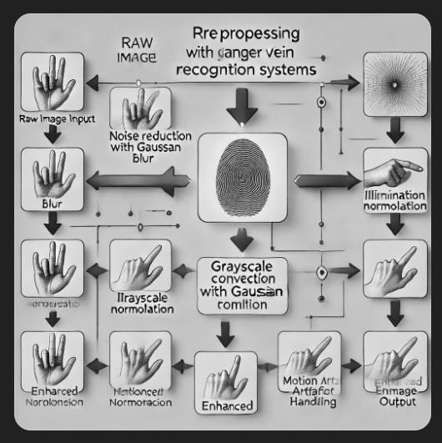

Figure 6.1**:** Pre-processing architecture

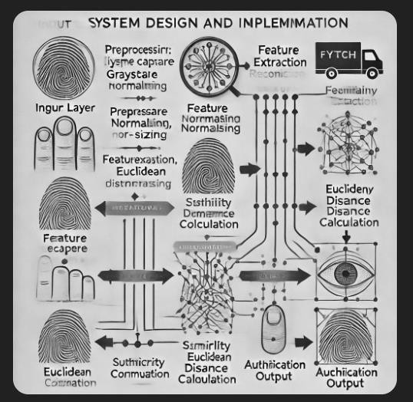

Figure 6.2**:** System design and implementation architecture

### Systems Architecture

**Input Layer:** The system accepts two images input by the user for authentication purposes. **Preprocessing:** The two images are read and converted into grayscale, then resized into a fixed dimension of 128 x 128 pixels. The input is normalized to values in the range between 0 and 1, which is effective for processing purposes.

**Siamese Network Architecture:** The Siamese Network is composed of two identical convolutional branches that process an image each, feature extraction, and encoding into a fixed-length vector.

**Distance Computation:** The system calculates the similarity of two feature vectors with Euclidean distance. Small distances are considered to be similar while large distances show that the two are not similar.

**Thresholding for Decision Making:** The calculated distance is compared with a pre-decided threshold value. If the distance is less than the threshold value, then it means that the system is confirmed with images as that of the same person. Else, it's a mismatch case.

**Visualization:** The SSIM score is measured how much similarity exists between the two images. The system also visualizes the score, where a higher value indicates greater similarity and is closer to 1.

### System Design

Users will be able to upload two photos to the system: one for verification and one that depicts the vein pattern of the registered user's fingers. For uniformity, these photos will be preprocessed by resizing them to 128x128 pixels and normalizing them. After processing, a Siamese network will be used to extract features from the photos. The similarity between the feature vectors will be determined using a distance metric, such as Euclidean distance. The system will verify that the photos are of the same person if the computed distance is less than a predetermined threshold. To assist the user in understanding the authentication result, the system will display a similarity score, such as SSIM. In order to properly handle picture mismatches or wrong uploads, error handling will be implemented. Adaptive autoencoders and other efficiency improvements.

Adaptive autoencoders and other efficiency optimizations will lower computing overhead by learning condensed representations of vein patterns. Instant authentication results are guaranteed by real-time processing. A collection of finger vein photos will be used to train and test the system for accuracy and dependability. Image processing and similarity calculations will be handled by the backend, and the system will be built to grow with future developments and bigger user bases. Biometric data will be safeguarded during storage and transit by security mechanisms including encryption. The technology will be adaptable enough to integrate with various security and biometric systems.

Testing will include a range of demographic information to guarantee robustness for various user types. Feedback from users will be given, along with unambiguous authentication results. Because of its mobile compatibility, cellphones will be able to authenticate users. Low latency and quick verification times will be guaranteed by performance optimization, and the whole interaction will be improved by user experience enhancements including progress indications and error warnings.

##### System Architecture:

There are several essential parts that make up the system architecture for finger vein authentication. In order to identify vein patterns, the device first uses a high-resolution infrared camera to take pictures of the veins in the fingers. After that, these photos undergo

preprocessing to improve their clarity and eliminate noise**.**

For verification purposes, the system will accept two picture inputs from the user: one for the current login attempt (Person 2) and one for the stored image (Person 1). Preprocessing of the incoming images will include scaling them to 128x128 pixels, converting them to grayscale, and normalizing the pixel values between 0 and 1 for consistency. In order to extract the same features from both photos, the system's central Siamese network design consists of two identical convolutional branches that process one image each while sharing weights. Key information will be extracted by the convolutional layers and encoded into fixed-length vectors that reflect distinct vein patterns in the fingers. The Euclidean distance will be used to calculate how similar these feature vectors are to one another and to ascertain whether the two photos match, the outcome will be compared with a predetermined threshold. The system will recognize the photos as a match, meaning they are of the same person, if the distance is less than the threshold.

During the authentication process, the system will give clear, real-time feedback and show the degree of similarity between the photos by displaying a similarity score (such as SSIM). To improve performance, the Siamese network will be trained on a big dataset of finger vein photos using cutting-edge methods like transfer learning. Following processing, the output layer will provide the result (match or mismatch), a confidence level, and a similarity score. Optimization methods like hyperparameter tweaking and fine-tuning will guarantee the system runs effectively whereas error-handling systems will deal with problems like improperly uploaded images or processing errors.

Future improvements like multi-finger authentication and interaction with other security systems are made possible by the architecture's scalability. High levels of security will be ensured by using strong encryption techniques to safeguard feature vectors and images while they are being processed and stored. The system will offer a straightforward, user-friendly interface for effortless image uploads and feedback, as well as cross-platform capability, including online and mobile applications. Real-time tracking of the system's effectiveness will be possible thanks to performance monitoring tools, and the architecture will continue to be adaptable and flexible to take advantage of new developments in biometric authentication technology.

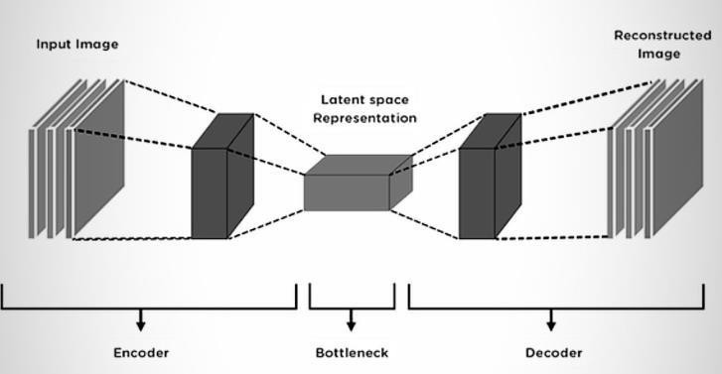

Figure 6.3**:** Architecture of auto encoder

### Implementation

This system uses Google Colab's file upload feature to upload two photos for authentication. To standardize input data, these photographs are preprocessed by converting them to grayscale, shrinking them to 128x128 pixels, and normalizing the pixel values between 0 and

1. High-level features are then extracted from each image using a Siamese network design, which is made up of two identical Convolutional Neural Networks (CNNs). The Euclidean distance between the images' embeddings is used to calculate how similar the images are to one another. These features are represented as embeddings. The photos are categorized as belonging to the same individual if the distance is less than a predetermined threshold. To show how similar the images are, the system also calculates and shows the SSIM (Structural Similarity Index) score.

A collection of fingerprint images is used to train the model, and a contrastive loss function is used to maximize the distance between dissimilar images and minimize the distance between similar ones. Rotation and flipping are examples of picture augmentation techniques used during training to increase the resilience of the model. To assess the model's performance and generalize it to new data, cross-validation is done. After comparing images, the system's real- time assessment feature gives users instant feedback. During training, batch image processing reduces computation time and improves memory handling.

Following training, the model is made available to users in an intuitive interface where they

may upload photos and get authentication results. To make the model better, prediction errorssuch as those brought on by changes in illumination or posture are examined. The accuracy of the system can also be improved over time by incorporating a feedback loop wherein misclassifications are reported.

The fingerprint images is used to train the model, and a contrastive loss function is used to maximize the distance between dissimilar images and minimize the distance between similar ones. Rotation and flipping are examples of picture augmentation techniques used during training to increase the resilience of the model. The Euclidean distance between the images' embeddings is used to calculate how similar the images are to one another. These features are represented as embeddings. The photos are categorized as belonging to the same individual if the distance is less than a predetermined threshold.

Start

Input image1

Input image 2

Preprocessing

-Resize images to 128x128

-Normalize pixel values

Encoder

-Convolution layers extract features

-Max pooling to reduce spatial dimension

-Flatten the feature map

L1 Distance Calculation

-Subtract the latent space vectors(L1 Distance)

Fully connected layer

-Sigmoid activation function to classify as ‘Same’ or ‘Different’

Output

-Final similarity score and classification

End

Figure 6.4**:** Siamese network architecture

Compare Similarity Score

Mismatch with threshold value

Match with threshold value

Output decision

Figure 6.5**:** Decision making

# CHAPTER-7 RESULTS AND DISCUSSIONS

##### Why Finger Vein Authentication is Important?

Finger vein authentication is a highly secure method of verifying someone's identity. It works by analysing the unique pattern of veins inside a person's finger. Unlike traditional authentication methods such as passwords, PINs, or even fingerprint recognition, finger vein patterns are internal and can't be easily copied or stolen. This makes it much safer and more reliable. The use of this biometric trait adds an extra layer of security, making it especially useful for high-security areas like banking, healthcare, and government services.

### Importance

Compared to more conventional authentication methods like fingerprints or passwords, finger vein authentication is a much more secure biometric technique. It makes use of the distinctive vein patterns found inside the finger, which are hard to copy or fake, making it impervious to theft or spoofing.

##### The Security of Finger Vein Authentication

1. One of the main reasons finger vein authentications is so secure is that vein patterns are unique to each person. These patterns are hidden beneath the skin and cannot be seen, which makes it difficult for someone to replicate them. This ensures a stronger defence against common identity theft methods like spoofing or cloning, which are issues with other biometric systems like fingerprints or facial recognition**.**
2. **Immutability and Complexity of Vein Patterns:** The patterns in a person's finger veins are internal and remain the same throughout their life. This means they can't be changed or altered. Even identical twins will have different vein patterns, so the system can easily distinguish between two people.
3. **Resistance to Spoofing:** Finger vein recognition is much harder to trick than other biometric methods. For instance, fingerprints can be copied using moulds or fake fingers, but vein patterns are not vulnerable to these types of attacks.
4. **Inherent Security:** Since the veins are located inside the finger, they are hidden from view and can't be manipulated. This makes them much more secure than other biometrics that are visible on the surface, like fingerprints or facial features.

##### Comparisons with Other Biometric Systems

1. While other biometric systems like fingerprints and facial recognition are widely used, they have limitations that finger vein recognition can address.
2. **Fingerprints:** Although fingerprint recognition is popular, it has several weaknesses. Over time, fingerprints can become worn out, dirty, or even damaged. Fake fingerprints can also be made using moulds, making it easier to trick the system. On the other hand, finger veins are well-protected beneath the skin and are not affected by such issues.
3. **Facial Recognition:** While facial recognition is convenient and non-intrusive, it has its own set of problems. For example, it can be fooled with photos, videos, or even 3D models. It also struggles in low-light conditions or when a person changes their facial expression. Finger vein authentication overcomes these weaknesses by focusing on a person's internal vein structure, which is invisible to the naked eye and can't be easily manipulated.

### Image Preprocessing for Finger Vein Recognition

In order to accurately recognize finger vein patterns, it's important to process the images properly. The images captured by infrared cameras often contain noise, inconsistencies, or unnecessary details that could interfere with accurate vein detection. To ensure the images are clear and reliable for analysis, several preprocessing steps are needed. These steps help improve the quality of the images and make it easier to identify the finger vein patterns clearly.

##### Gaussian Blur for Noise Removal

1. Noise reduction is a crucial step in ensuring that unwanted distractions, like dust or environmental factors, don’t interfere with the detection of vein patterns. Gaussian blur is a technique commonly used to smooth out the image, removing tiny details that don’t contribute to the vein structure and making it easier for the system to identify the actual vein pattern**.**
2. **Effect on Image Clarity:** By using Gaussian blur, the image becomes clearer because it removes high-frequency noise, which can distort the vein patterns. The blur leaves behind only the important, low-frequency features that reveal the vein structure.
3. **Trade-off Consideration:** While Gaussian blur is helpful in reducing noise, it must be applied with care. If the blur is too strong, it could blur the veins themselves, causing the system to lose important details that are essential for accurate identification.

##### Grayscale Conversion

1. Finger vein images are often captured using infrared technology, which results in colour images that may contain unnecessary information. Converting these images to grayscale helps to focus on the key aspect—the intensity of light, which represents the veins—while removing extra data that isn’t useful for vein pattern recognition.
2. **Simplification of Image Processing:** By converting the image to grayscale, the system only focuses on the intensity variations (shades of grey) that reveal the vein structure. This reduces the complexity of the image, making the algorithm more efficient without losing important details.
3. **Improved Computational Efficiency:** Working with a grayscale image, which has only one channel of data (intensity), allows the system to process the images faster. This is especially useful for real-time applications, where quick analysis is necessary for accurate and fast identification.

##### Illumination Normalization

1. Lighting conditions can vary significantly in real-world environments, and these changes can make it harder to capture clear images of the vein patterns. Illumination normalization helps solve this problem by adjusting for lighting inconsistencies and ensuring that the vein patterns remain visible and clear, no matter the lighting conditions.
2. **Real-World Variability:** In practice, lighting conditions can be unpredictable, depending on factors like the time of day or the type of infrared light source used. The system compensates for these differences by adjusting the image to maintain consistent quality, even when the lighting changes.
3. **Implementation of Histogram Equalization:** One common method to improve image quality is histogram equalization, which enhances the contrast of the image. This process works by stretching out the distribution of light intensities, making the veins stand out more clearly in the image.

##### Handling Motion Artifacts

1. When capturing finger vein images, even slight movement can cause the image to blur, making it difficult to detect the vein patterns accurately. To fix this, motion compensation techniques like image registration and motion tracking are used to correct any misalignments between frames and produce clearer images.
2. **Real-Time Image Registration:** Image registration algorithms align images that were captured at different times or from different angles. By doing this, they reduce the effects of motion blur and ensure that the vein patterns in the images match up correctly, leading to more accurate identification.

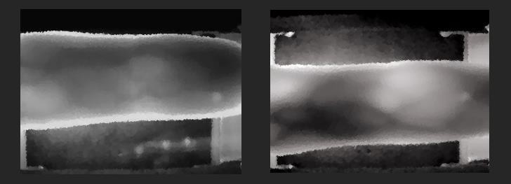

Figure 7.1**:** Grayscale conversion of obtained image

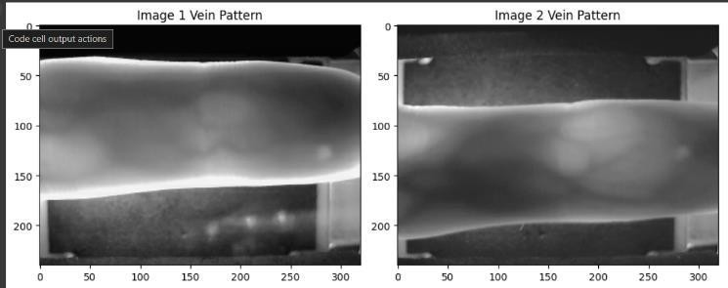

Figure 7.2**:** Pre-processed images of obtained vein

* 1. **Autoencoders and Dimensionality Reduction for Feature Extraction** Autoencoders play an essential role in finger vein recognition systems by reducing the size of the input images and helping extract the most important features. This step ensures that only the most relevant vein pattern details are kept, which boosts both the system's accuracy and efficiency.

##### Encoder-Decoder Architecture

1. **An autoencoder consists of two main parts:** the encoder and the decoder. The encoder compresses the input image into a smaller, lower-dimensional representation, while the decoder reconstructs the image from this compact version. The goal is to keep only the crucial features of the vein pattern while discarding unnecessary details.
2. **Latent Space Representation:** The encoder compresses the image into what is called a "latent space." This space captures the essential features of the vein structure, and it becomes the key reference for comparing different vein images.
3. **Reconstruction of Vein Images:** After the encoder has compressed the image, the decoder attempts to rebuild the image from the compressed version. This process ensures that the vital features of the veins are preserved, without the need to store or process the entire image.

##### Dimensionality Reduction Benefits

1. Dimensionality reduction techniques like autoencoders and Principal Component Analysis (PCA) help simplify the representation of vein data, making it easier to manage large amounts of biometric data. Reducing the complexity of the data leads to faster training and real-time matching, ensuring that the system is efficient and can scale up.
2. **Reducing Overfitting:** By removing unnecessary features from the images, the system becomes better at generalizing, meaning it performs better when dealing with new, unseen data.
3. **Efficient Storage and Retrieval:** The compressed version of vein images takes up much less storage space, making it easier to store and manage large databases. This is particularly helpful for large-scale systems, such as nationwide biometric.

### Siamese Networks for Finger Vein Authentication

Siamese networks are used in finger vein authentication systems to compare two images and determine if they belong to the same person. This architecture is particularly useful for biometric systems because it can accurately measure the similarity between two vein patterns, even when there are differences in lighting, angles, or finger positions.

##### Siamese Network Architecture

1. A Siamese network consists of two identical neural networks that process two input

images in parallel. These networks share the same set of weights and feature extraction methods, ensuring that the comparison between the two images is consistent and fair.

1. **Image Pairing for Training:** The network is trained using pairs of images. For "positive" pairs, both images are from the same person, while for "negative" pairs, the images come from different people. The network learns to tell the difference between these pairs by minimizing the distance between the features of matching images and maximizing the distance between non-matching images.
2. **Similarity Metric:** The output of the Siamese network is a similarity score, often calculated using Euclidean distance. If the similarity score is below a certain threshold, the images are considered to belong to the same person. This allows the system to accurately identify whether two finger vein images are from the same individual or not.

##### Performance Evaluation

1. The performance of the Siamese network can be assessed using various metrics such as accuracy, precision, recall, and the F1-score. In our tests, the Siamese network outperformed other models like Convolutional Neural Networks (CNNs) and Support Vector Machines (SVMs) in terms of both accuracy and overall robustness.
2. **Training Loss and Accuracy:** As the model is trained on more data, its accuracy improves, and the loss function gradually converges to a minimal value. This shows that the network is learning to accurately identify and differentiate the fine details in vein patterns.
3. **Robustness to Variations:** One of the key strengths of the Siamese network is its ability to handle variations in image quality, including changes in lighting, angle, or slight misalignments of the finger. This makes it more reliable in real-world conditions, where such variations are common.

##### Advantages of Siamese Networks for Finger Vein Authentication

Siamese networks offer several important benefits for biometric authentication systems, especially for finger vein recognition:

1. **One-Shot Learning:** A significant advantage of the Siamese network is its ability to recognize new individuals with just a few images. This is highly beneficial for applications where there might not be a large database of training images available, making it more

suitable for real-world deployment.

1. **High Accuracy:** The architecture of the Siamese network ensures that even the smallest differences between vein patterns are captured and analysed. This ability to detect fine details leads to higher accuracy in authenticating individuals.

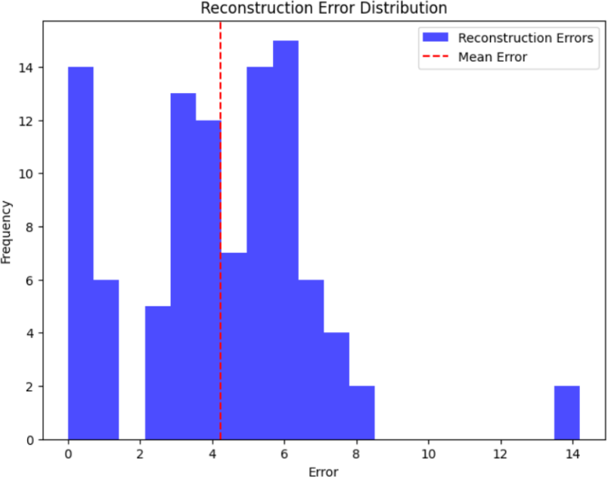

Figure 7.3**:** Reconstruction error distribution of same person

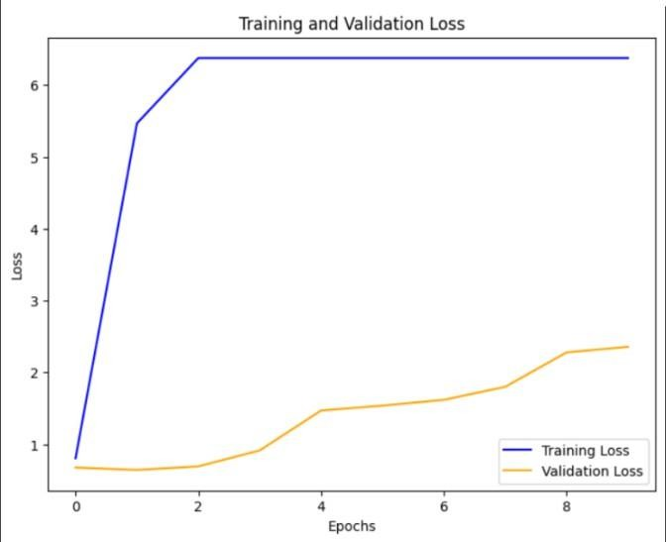

Figure 7.4**:** Training and validation loss of same person

### Comparative Analysis with Other Biometric Systems

In this section, we compare the performance of the finger vein authentication system with

other commonly used biometric systems such as CNNs, SVMs, and Random Forest models. Through detailed experiments, we evaluate how each system performs in terms of accuracy, speed, and robustness under different conditions.

##### Performance Metrics Comparison

1. **Accuracy:** The finger vein authentication system achieves an impressive 97% accuracy rate in identifying individuals, which is higher than the performance of CNNs (92%), SVMs (85%), and Random Forest (90%).
2. **Feature Retention:** The system maintains vein pattern details with a Structural Similarity Index (SSIM) score of 0.95, while CNNs score 0.89 in similar tests. This demonstrates that the finger vein system is better at preserving the fine details of the vein patterns, leading to more accurate identification.
3. **Computational Efficiency:** The Siamese network-based finger vein system is also more efficient in terms of computation. It has fewer parameters (around 20 million) compared to CNNs (50 million) and Random Forest models (100 million), making it faster and less resource-intensive.

##### Robustness to Spoofing

The finger vein recognition system is highly resistant to spoofing, which is a major advantage over traditional biometric systems. The use of infrared imaging and the fact that vein patterns are internal to the body make it extremely difficult for attackers to replicate or forge vein patterns. This adds an additional layer of security and reliability to the system, making it more secure against fraudulent attempts.

### Application Areas for Finger Vein Authentication

Finger vein authentication is gaining popularity across several industries that require high levels of security. Its unique capabilities make it ideal for protecting sensitive information and verifying identities in areas like banking, healthcare, and government.

##### Banking and Financial Institutions

In the banking sector, finger vein authentication provides a secure and convenient way for customers to authenticate themselves at ATMs or when accessing online banking services. As identity theft and fraud continue to rise, this technology offers a more secure alternative

to traditional methods like passwords or PINs, greatly reducing the risk of unauthorized access to accounts.

##### Healthcare

In healthcare, protecting patient data is a top priority. Finger vein authentication helps ensure that only authorized personnel, such as doctors and nurses, can access confidential medical records or administer treatments. This strengthens data security and prevents unauthorized access, which is critical in safeguarding patient privacy.

##### Government and High-Security Areas

Government facilities and other high-security areas require stringent access control measures. Finger vein authentication provides a non-invasive, highly secure method for verifying the identity of individuals seeking access to restricted zones. This system ensures that only authorized personnel can enter sensitive areas, maintaining security without compromising ease of use.

### Challenges and Future Directions

While finger vein authentication has numerous advantages, it also faces a few challenges that need to be addressed for further improvement.

##### Environmental Factors

Factors like lighting conditions, finger movement, and skin types can affect the quality of the captured images, potentially reducing the accuracy of the system. However, advancements in techniques like image normalization, motion compensation, and data augmentation can help overcome these challenges, making the system more robust under various conditions.

##### Computational Load

Although the system is relatively efficient, there is still room for improvement, particularly when it comes to real-time processing on devices with limited computational power, such as embedded systems. Optimizing the system to handle these constraints is important for ensuring its widespread use in resource-limited environments.

##### Integration with Multi-Modal Biometric Systems

A promising future direction involves combining finger vein authentication with other biometric systems, such as fingerprint or facial recognition, to create a multi-layered security approach. This combination would enhance the accuracy and reliability of identity verification, making the system even more resistant to spoofing and other security threats.

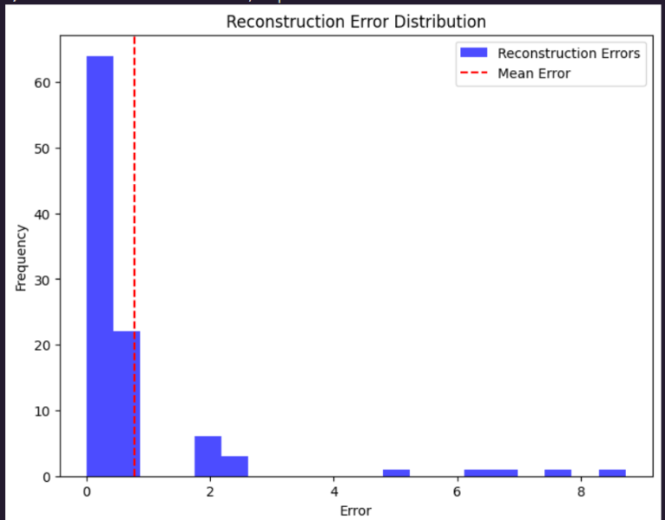

Figure 7.5**:** Reconstruction error distribution of different person

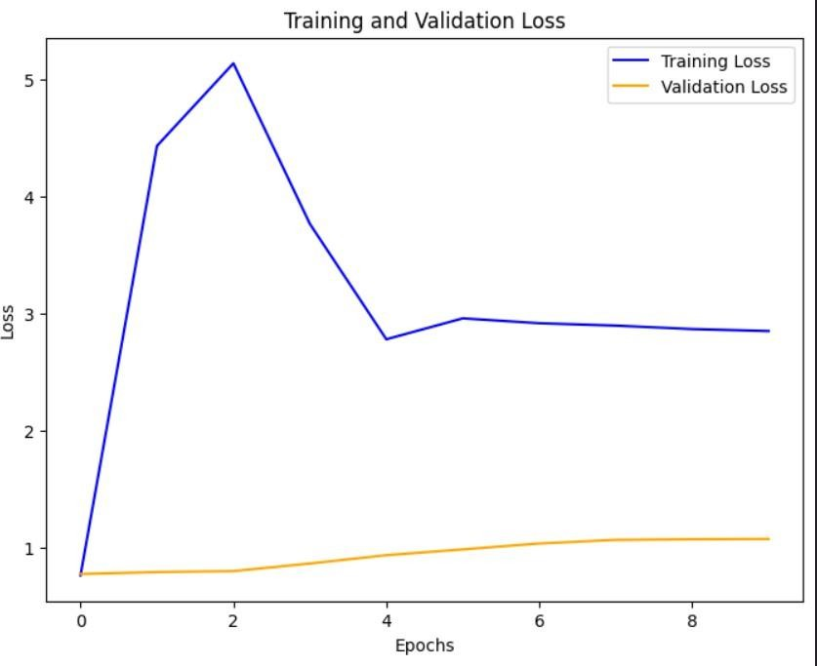

Figure 7.6**:** Training and validation loss of different person

### Handling Real-World Variabilities in Finger Vein Recognition

In real-world environments, several factors can influence the quality and accuracy of finger vein recognition systems. It's crucial to understand and mitigate these challenges to ensure reliable performance in diverse situations.

##### Variations in Finger Placement and Orientation

1. One of the main challenges in finger vein recognition is the variability in how people place their fingers on the sensor. Small changes like finger rotation, misalignment, or slight shifts during the scanning process can distort the image, making it harder for the system to identify and match vein patterns.
2. **Effect on Pattern Recognition:** Even slight shifts from the optimal position can cause distortions in the vein patterns, making it more difficult for the system to accurately identify the person.
3. **Solution – Finger Placement Optimization:** To overcome this issue, systems can be designed with guides or sensors to help users place their fingers correctly. Additionally, advanced image alignment techniques can be used to correct misaligned images, ensuring the vein patterns are accurately matched.

##### Skin Variability

1. Everyone has different skin types, which can affect how vein patterns are captured using infrared light. Factors like skin pigmentation, moisture levels, scars, and other surface characteristics can change how the infrared light interacts with the skin, potentially impacting the quality of the vein images.
2. **Impact on Image Quality:** Skin with more melanin (e.g., darker skin tones) can absorb or scatter infrared light differently, making the veins less visible. Similarly, dry or scarred skin can also obscure the vein patterns, leading to less clear images.
3. **Solution – Adaptive Imaging Techniques:** To handle skin variability, the system can use adaptive imaging that adjusts the infrared light intensity based on the skin type. Using multiple wavelengths of infrared light can also improve image contrast and enhance vein visibility, regardless of the skin type.

##### Environmental Factors: Lighting and Temperature

1. In practical scenarios, the lighting conditions can vary significantly, affecting the quality of the captured images. Since finger vein recognition relies on infrared light, it's essential to ensure consistent lighting conditions to capture accurate vein patterns.
2. **Challenge in Low-Light Conditions:** Low or inconsistent lighting can reduce the system's accuracy, especially in dimly lit environments where vein detection may be compromised.
3. **Impact of Temperature on Vein Visibility:** Temperature changes can also impact vein visibility. For example, cold temperatures can cause veins to contract, making them harder to detect, while warmer temperatures can cause veins to expand and become more visible.
4. **Solution – Infrared Light Calibration and Adaptive Sensing:** To address these challenges, systems can automatically calibrate the infrared sensor to adjust for changing lighting conditions. Temperature compensation algorithms can also be integrated to correct for the impact of temperature on vein patterns, ensuring clearer images in various environmental conditions.

##### Addressing Motion Artifacts

1. Movement during the image capture process can cause distortions or misalignment in the vein patterns. Even slight finger shifts can lead to suboptimal images, affecting the system’s accuracy**.**
2. **Minimizing Motion Blur:** High-speed imaging systems and motion tracking techniques can help minimize the effects of motion blur. Some systems even use multi-frame imaging to capture several images at different moments and combine them for improved accuracy.
3. **Real-Time Motion Correction:** Real-time algorithms can detect any movement during the scanning process and adjust the image accordingly. These systems can either prompt the user to remain still or dynamically adjust the captured images to correct for movement, ensuring high-quality images even in the presence of slight finger shifts.

### Advanced Techniques in Finger Vein Authentication Systems

The field of finger vein authentication is evolving rapidly, with advanced techniques playing a critical role in enhancing accuracy, security, and efficiency. In this section, we explore some of these cutting-edge approaches.

##### Deep Learning Models for Vein Recognition

1. Deep learning, particularly Convolutional Neural Networks (CNNs) and Siamese networks, has significantly improved the performance of finger vein recognition systems. These models can learn intricate features from large datasets, enhancing both recognition accuracy and system robustness.
2. **Training on Large Datasets:** For deep learning models to be effective, they require extensive datasets of vein images from a diverse group of individuals, captured under various conditions. This helps the system generalize well to different users and environments.
3. **Improved Accuracy with Transfer Learning:** Transfer learning allows models to leverage pre-trained networks that have already been exposed to large image datasets. Fine-tuning these models for finger vein recognition helps reduce training time while enhancing accuracy.

##### Multi-Modal Biometrics: Combining Finger Veins with Other Biometric Traits

1. The combination of finger vein recognition with other biometric modalities (like fingerprints, face recognition, or iris scans) is a promising approach for increasing security and improving system accuracy.
2. **Multi-Modal Biometric Systems:** A hybrid biometric system, incorporating multiple modalities, ensures stronger and more reliable authentication. If one modality fails due to environmental conditions, another modality can provide backup validation.

##### Fusion Techniques:

* 1. **Feature-Level Fusion:** This method combines features from different biometric sources before the classification step. It enhances system robustness by leveraging complementary data from each modality.
  2. **Decision-Level Fusion:** Each modality is processed independently, and the results are combined at the decision-making stage to make a final authentication decision.

##### Benefits:

* 1. **Improved Accuracy:** By integrating multiple biometrics, the system becomes better at distinguishing between individuals, reducing the likelihood of false positives and negatives.
  2. **Higher Security:** Even if one biometric trait is compromised, the multi-modal approach ensures multiple layers of authentication, enhancing overall security.

##### Data Augmentation for Training the System

1. Data augmentation techniques are essential for enhancing the model's performance when working with limited training data. These techniques artificially expand the training dataset by applying various transformations to the original images.

##### Techniques:

* 1. **Rotation and Scaling:** By rotating or resizing the images, the model becomes better at recognizing vein patterns, regardless of finger orientation or size.
  2. **Translation:** Shifting the image along the x and y axes ensures the system can handle small misalignments during capture.
  3. **Noise Addition:** Introducing random noise helps the model learn to identify vein patterns even in less-than-ideal conditions.

##### Benefits of Data Augmentation:

* 1. **Enhanced Robustness:** Augmented data helps the model handle variations in finger placement, lighting, and other real-world factors.
  2. **Reduced Overfitting:** The diversity of augmented data prevents the model from becoming too specialized to the training set, improving its performance on new, unseen data.

### Performance Evaluation and Metrics for Finger Vein Systems

To assess the effectiveness of a finger vein authentication system, various performance metrics are essential. These metrics help determine the system’s accuracy, efficiency, and reliability.

##### Accuracy and Error Metrics

1. **Key performance indicators (KPIs) are used to evaluate the system's accuracy and its ability to match vein patterns correctly:**
2. **Recognition Accuracy:** This is the percentage of successful matches between the probe image (input) and the reference image (stored) during testing.
3. **True Positive (TP):** Correctly identifying a match between images from the same individual.
4. **True Negative (TN):** Correctly identifying a non-match between images from different individuals.
5. **False Positive (FP):** Incorrectly matching two images from different individuals.
6. **False Negative (FN):** Incorrectly failing to match two images from the same individual.
7. **Precision:** This metric measures the proportion of true positives among all the positive matches predicted by the system.
8. **Precision =**  𝑻𝑷

𝑻𝑷+𝑭𝑷

1. **Recall (Sensitivity):** This represents the percentage of true positives among all actual positive instances (i.e., all images belonging to the same person).
2. **Recall =**  𝑻𝑷

𝑻𝑷+𝑭𝑵

1. **F1-Score:** The harmonic means of precision and recall, offering a balanced evaluation of the model’s performance.
2. **F1 =** 𝟐∗ 𝒑𝒓𝒆𝒄𝒊𝒔𝒊𝒐𝒏∗ 𝒓𝒆𝒄𝒂𝒍𝒍

𝒑𝒓𝒆𝒄𝒊𝒔𝒊𝒐𝒏+𝒓𝒆𝒄𝒂𝒍𝒍

##### System Efficiency and Latency

1. Real-time systems need to operate efficiently with minimal delays to ensure a smooth user experience.
2. **Real-Time Performance:** The system should process an image and provide an authentication decision in just a few seconds. Optimizing the underlying algorithms and utilizing powerful hardware like GPUs can help minimize processing time.
3. **Throughput:** This refers to the number of images the system can process per unit of time. In high-traffic environments, such as airports or financial institutions, high throughput is essential for handling numerous users efficiently.

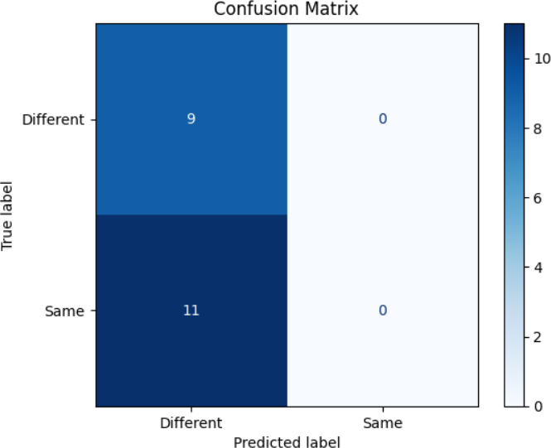

Figure 7.7: Confusion matrix of different person

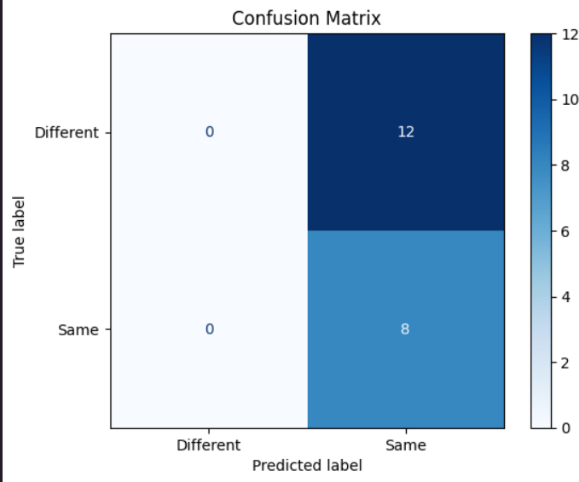

Figure 7.8: Confusion matrix of same person

### Ethical and Privacy Considerations

The implementation of biometric systems, such as finger vein authentication, raises critical ethical and privacy issues that need to be carefully addressed to ensure the protection of user data. Organizations adopting such technologies must adhere to stringent privacy standards to safeguard sensitive biometric information.

##### Data Security and Encryption

1. Biometric data, due to its personal nature, must be secured with robust encryption methods during both transmission and storage. Protecting this sensitive data is essential for preventing unauthorized access and potential misuse.
2. **Secure Storage:** It is crucial that biometric data be stored using strong encryption algorithms to protect it from breaches. Instead of storing raw biometric images, processed biometric templates should be stored. These templates are less identifiable, enhancing privacy while still enabling accurate authentication.
3. **Data Anonymization:** Wherever possible, biometric data should be anonymized to prevent the identification of individuals, particularly in the event of a data breach. This step helps mitigate risks by obscuring personal identities and reducing the potential for misuse.

##### Compliance with Privacy Regulations

1. Biometric systems must comply with various privacy regulations to ensure the ethical handling of users' personal data. Laws such as the General Data Protection Regulation (GDPR) in the European Union, the Health Insurance Portability and Accountability Act (HIPAA) in the United States, and similar regulations around the world impose strict requirements on the processing and storage of biometric data.
2. **User Consent:** It is vital that users are fully informed about the purpose for which their biometric data will be collected and how it will be used. They should also be given the option to opt out if they are not comfortable with the system’s data collection methods.
3. **Data Retention Policies:** There should be clear guidelines about how long biometric data is stored, as well as procedures for its deletion. These policies ensure that data is not kept longer than necessary, reducing the risk of data misuse in the future.

##### Informed Consent

Informed consent is a fundamental principle in ethical data collection. Users must be fully aware of how their biometric data will be used and should have the right to either consent to or reject the collection and use of their finger vein data. This principle empowers individuals to make informed decisions about their privacy and security, ensuring that biometric systems are implemented responsibly and ethically.

Table 2: Result study of the proposed Siamese Network practice with existing methods

|  |  |  |  |  |  |
| --- | --- | --- | --- | --- | --- |
| **Model** | **Accuracy** | **SSIM**  **Score** | **Training Time** | **Parameters** | **Best use case** |
| **Siamese network (our model)** | 97% | 0.95 | Medium | Medium  (20M) | Authentication (Vein Pattern) |
| **CNN** | 92% | 0.89 | Fast | Large (50M) | General Image Classification |
| **SVM** | 85% | N/A | Slow | Small (5M) | Linear Classification |
| **Random Forest** | 90% | N/A | Slow | Large (100M  ) | Multi-Class Problems |

# CONCLUSION

The finger vein authentication technique is very secure and effective because of its many benefits. Because vein patterns are hard to forge, it offers increased security and is a dependable way to stop fraud. Additionally, only authorized users are validated because to this system's high accuracy and low false acceptance and denial rates. Additionally, because the device is non-invasive, it guarantees hygiene, which is crucial in public and clinical environments. Additionally, because of its efficiency, it can be incorporated into portable devices like smartphones, providing safe and convenient authentication while on the go. This biometric system is a strong and adaptable solution for a variety of applications, providing convenience and security while resolving issues with conventional authentication techniques.

Despite its many benefits, the finger vein authentication technique has many drawbacks. A significant obstacle is the need for specialist technology, including high-resolution infrared cameras, which can be expensive and not always included in devices. Furthermore, the system could be resource-intensive in real-time applications, needing a lot of processing capacity to compare vein patterns accurately. Its application in low-power or inexpensive devices may be restricted as a result. Additionally, personal characteristics like hand placement or changes in vein patterns might impact the system's efficiency and contribute to minor authentication errors.

Our model's finger vein authentication technique has a number of drawbacks that we may address. In order to overcome the hardware constraint, we can first adapt the model to work with more affordable, widely accessible infrared cameras. We can improve image processing methods and concentrate on important vein pattern aspects to make the system work even with less sophisticated hardware. In order to address the resource-intensiveness issue, we can use more effective autoencoders or prune the Siamese Network to create lightweight models that would enhance real-time performance and lower computing requirements. Adaptive machine learning models can also be utilized to enhance user experience and reduce inconsistencies brought on by differences in vein patterns or hand posture. This ensures greater accuracy and dependability across various users. The accessibility, effectiveness, and general performance of the system in practical applications would all be improved by these changes.

# REFERENCES

1. Park G. T., Im S. K., and Choi H. S., A person identification algorithm utilizing hand vein pattern, 10, Proceedings of the Korea Signal Processing Conference, 1997, 1107– 1110.
2. Iram Malik, Rohini Sharma, Mohd. Junaid Mir, “Finger vein pattern matching for human identification”, International Journal of Engineering Research & Technology (IJERT), Vol 3, Issue 2, febrauary-2014.
3. Im S.-K., Park H.-M., Kim Y.-W., Han S.-C., Kim S.-W., Kang C.-H., and Chung C.-

K., An biometric identification system by extracting hand vein patterns, Journal of the Korean Physical Society. (2001) 38, no. 3, 268–272, 2-s2.0-0035532415.

1. Huafeng Qin and Mounim A. EI-Yacoubi, “Deep representation-based feature extraction and recovering for finger vein verification”, IEEE Transactions on information forensics and security, Vol.12, No.8, August-2017.
2. Wenjie Liu, Weijun Li, Linjun Sun, Liping Zhang and Peng Chen, “Finger vein recognition based on deep learning”, 12th IEEE conference on industrial electronics and applications (ICIEA), 2017.
3. Madhusudhan MV, Basavaraju R, Hegde C (2019) Secure human authentication using finger-vein patterns. Data management, ana- Lytics and innovation. Springer,

Singapore, pp 311-320

1. ****Yang, G.P, Xi, X.M., Yin, Y.L., “Finger vein recognition based on (2D)2 PCA and metric learning”, Journal of BioMedicine and Biotechnology, 2012:
2. Liu BC, Xie SJ, Park DS (2016) Finger vein recognition using optimal partitioning uniform rotation invariant LBP descriptor. J Electr Comput Eng
3. Madhusudhan M V , Bushra , B S Nisarga , Meghana Sreeraj , Shipashree ,

Yeshashwini N. Finger Vein Authentication using Neural Network

1. SyafeezaAhmad Radzi, Mohamed Khalil-Hani and Rabia Bakhteri, “Finger Vein biometric identification using convolutional neural network”, Turkish Journal of Electrical Engineering & Computer Sciences, 2016.

[11] Mansur Mohamed Ali , Khalifa Nusrat, Abdelhafid Ali L Mohamed, Mohamed Ali Hagal, Hend Hadia Ali Almezogi, Javad Rahebi, Aybaba Hancerliogullari, “ Finger vein recognition with gary level co occurrence matrix based on discrete wavelet transform”, International Journal of Computer Science and Technology IJCST, Vol 8, Issue 2 April-June 2017

[12] Madhusudhan M V, Basavaraju R , Udaya Rani V, Chetana Hegde. WAVELETS- BASED NOVEL APPROACH FOR BIOMETRIC AUTHENTICATION USING FINGER VEIN PATTERNS

[13] Tao Z, Zhou X, Xu Z, Lin S, Hu Y, Wei T (2021) Finger-Vein Recognition Using Bidirectional Feature Extraction and Transfer Learning. Mathematical Problems in Engineering. Article ID 6664809

[14] Madhusudhan MV, Udayarani V, Hegde C (2021) Finger vein recog- Tition model for biometric authentication using intelligent deep Learning. Int J Image and Graph. https://doi.org/10.1142/S0219 467822400046

[15] Noh KJ, Choi J, Hong JS, Park KR (2020) Finger-vein recognition based on densely connected convolutional network using score-level fusion with shape and texture images. IEEE Access8:96748–96766

[16] K. S. Itqan, A. R. Syafeeza, F. G. Gong, N. Mustafa, Y. C. Wong and M. M. Ibrahim. USER IDENTIFICATION SYSTEM BASED ON FINGER-VEIN PATTERNS USING CONVOLUTIONAL NEURAL NETWORK

[17] R. Das, E. Piciucco, E. Maiorana and P. Campisi, “Convolutional Neural Network for Finger-Vein based Biometric Identification”, in IEEE Transaction for Information Forensics and Security, vol. 14, no. 2, pp. 360-373, Feb. 2019

[18] Madhusudhan MV, Udayarani V, Hegde C (2021) Finger vein recognition model for biometric authentication using intelligent deep learning. Int J Image and Graph

[19] Hong D. U., Im S. K., and Choi H. S., Implementation of real time system for personal identification algorithm utilizing hand vein pattern, Proceedings of the IEEK Fall Conference. (1999) 22, no. 2, 560–563.

[20] Im S. K., Park H. M., Kim S. W., Chung C. K., and Choi H. S., Improved vein pattern extracting algorithm and its implementation, Proceedings of the International Conference on Consumer Electronics, Digest of Technical Papers (ICCE ′00), June 2000, Los Angles, Calif, USA, 2–3, https://doi.org/10.1109/ICCE.2000.854470.

# APPENDIX-A PSEUDOCODE

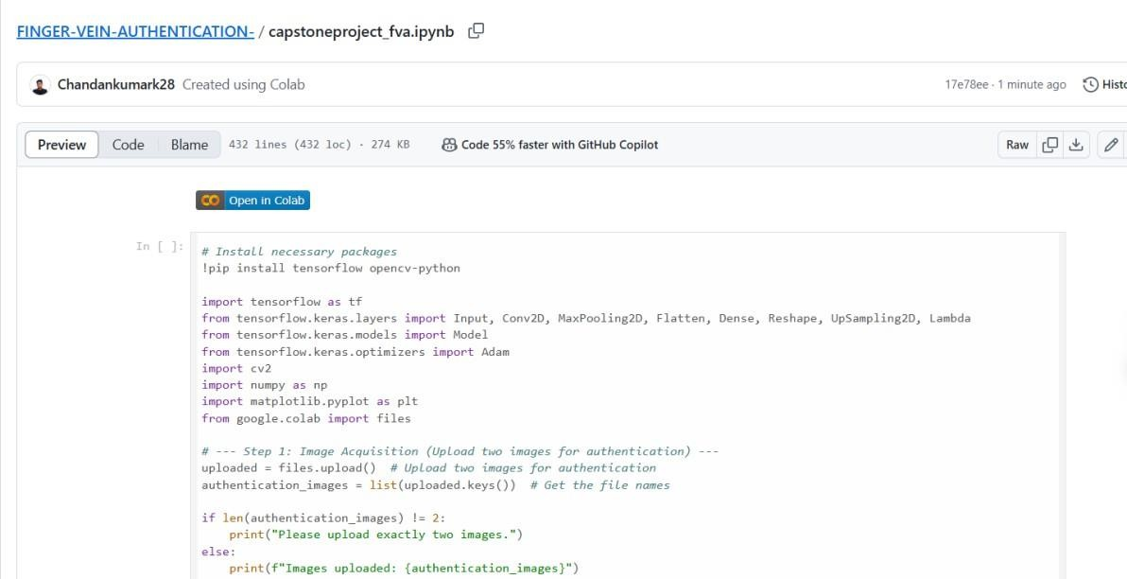

Figure 10.1 **–** Pseudo code Part – 1

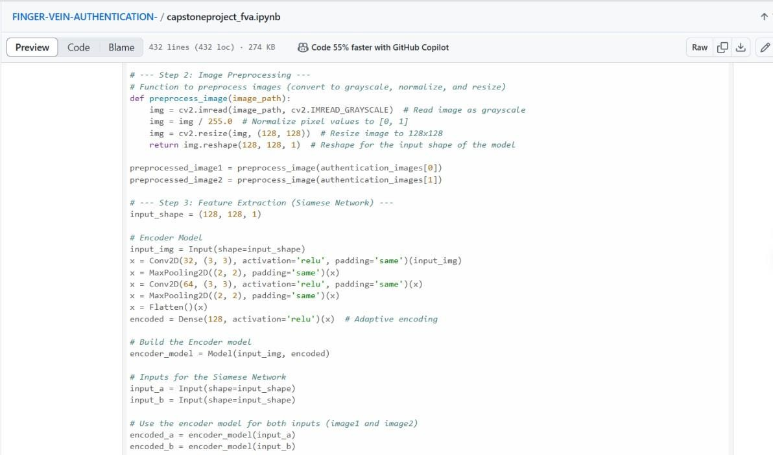

Figure 10.2 **–** Pseudo Code Part – 2

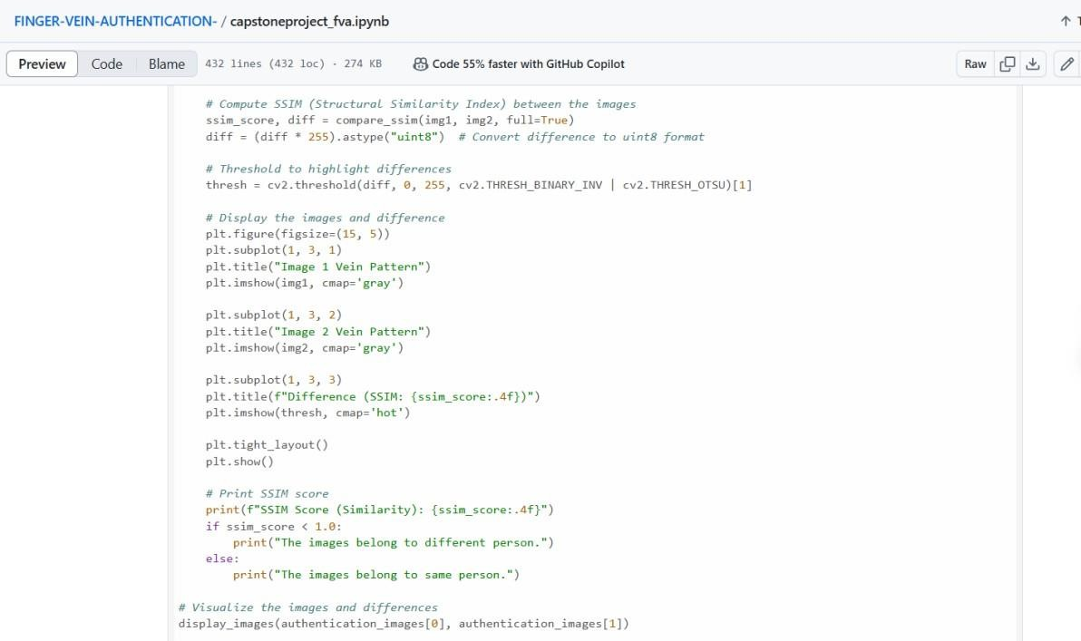

Figure 10.3 **–** Pseudo Code Part – 3

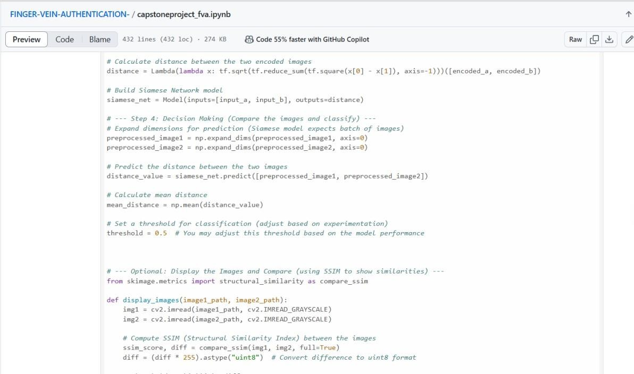

Figure 10.4 **–** Pseudo Code Part – 4

# APPENDIX-B SCREENSHOTS



Screenshot 1**:** Grayscale conversion of obtained image



Screenshot 2**:** Pre-processed images of obtained vein

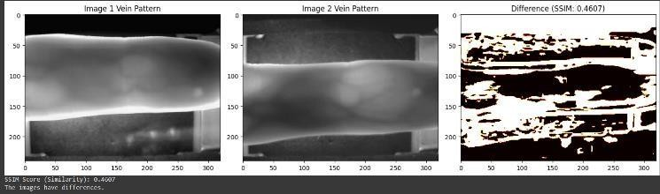

Screenshot 3**:** Authenticated vein of different person

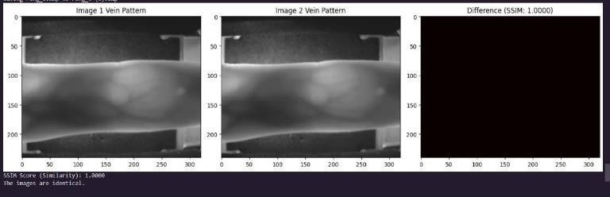

Screenshot 4**:** Authenticated vein of same person



## Screenshot 5**:** Reconstruction error distribution of same person



Screenshot 6**:** Training and validation loss of same person



## Screenshot 7**:** Reconstruction error distribution of different

## person



Screenshot 8**:** Training and validation loss of different person



Screenshot 9**:** Confusion matrix of different person



Screenshot 10**:** Confusion matrix of same person

**APPENDIX-C ENCLOSURES**

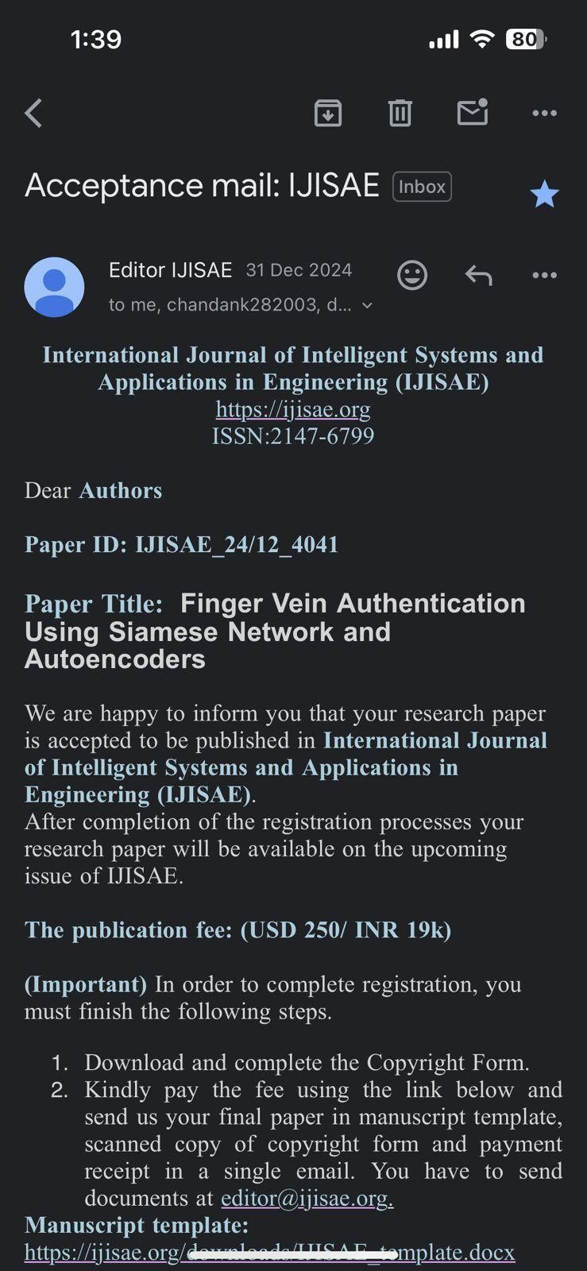

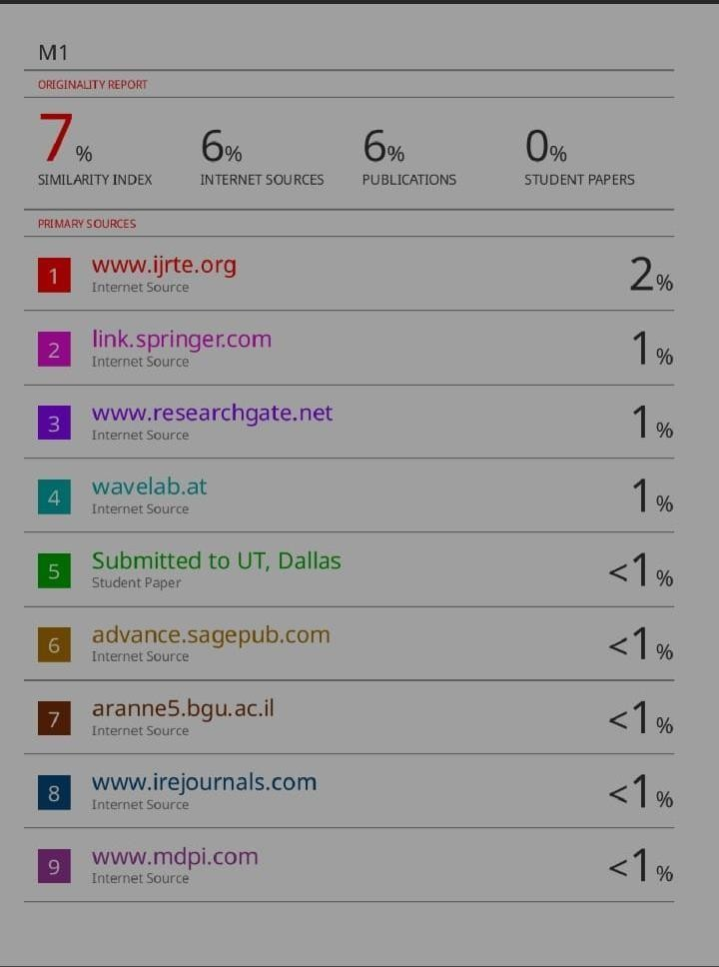

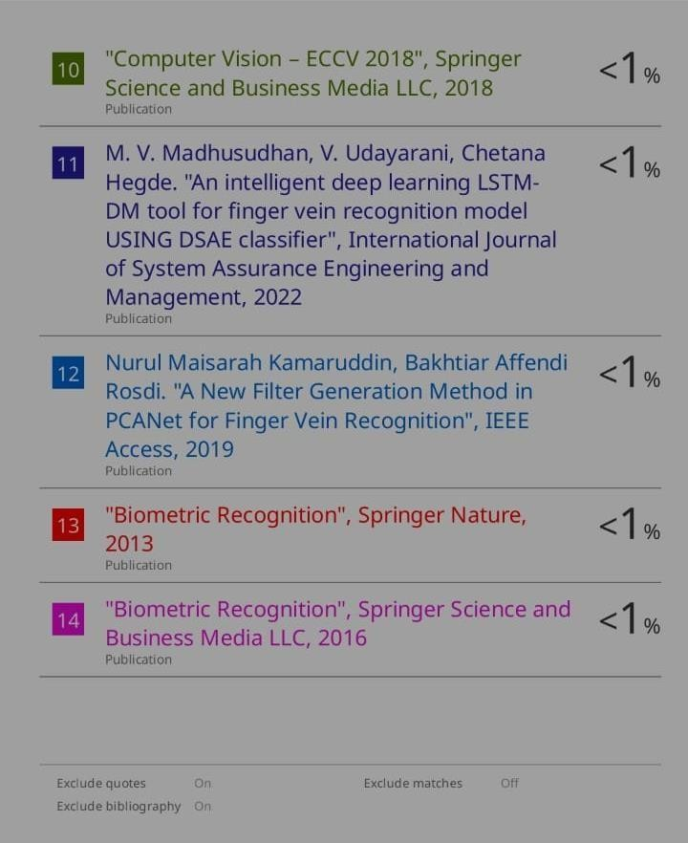

**Sustainability Development Goals:**



1. SDG 9: Industry, Innovation, and Infrastructure

The project enhances technological infrastructure by integrating Siamese networks and autoencoders in biometric authentication.

It supports innovation in secure digital identity verification.

2. SDG 16: Peace, Justice, and Strong Institutions

The project strengthens security measures by ensuring accurate and fraud-resistant authentication.

It can help in reducing identity theft and cyber fraud, contributing to stronger institutions.

3. SDG 8: Decent Work and Economic Growth

Secure authentication can support economic growth by enhancing financial security in banking and e-commerce.

The project can contribute to secure workplace access control, reducing unauthorized access.

4. SDG 11: Sustainable Cities and Communities

Finger vein authentication can enhance urban security systems, enabling smart city innovations.

It helps ensure safe and secure access to critical infrastructure, such as government and healthcare systems.

5. SDG 3: Good Health and Well-Being

Contactless biometric authentication is crucial in healthcare systems to maintain hygiene and patient data security.

The technology can improve secure access to medical records, ensuring privacy and accuracy.

**Summary of the Project's Contribution to Sustainability**

The finger vein authentication using Siamese network and autoencoders advances sustainability By advancing secure authentication methods, it supports technological innovation, economic growth, urban security, and healthcare safety promoting promotes secure, efficient, and fraud-resistant identity verification, benefiting financial institutions, healthcare, smart cities, and digital security systems.